

2025 High School Awards Judging Criteria

Every year, the Parrish recognizes and honors high school students for their dedication and passion for the arts. This year’s awards ceremony honors sixteen seniors for their artistic excellence and ten “Ones to Watch,” for outstanding students in ninth through eleventh grade. Honorees were selected by the Parrish’s associate curators, Kaitlin Halloran and Scout Hutchinson. Below are their thoughts on the judging process.

“Each year as the Student Art Exhibition approaches, there is great excitement across the Parrish Art Museum. As we mark the 72nd annual exhibition, this year’s student artists have excelled in bringing unique and thought-provoking works to the galleries. Congratulations to all those that participated and helped create another outstanding display of inspiring creative expression. As the Associate Curators of the Museum, we looked for originality and technical skill when selecting the awardees. We were especially impressed with the wide array of subject matter explored in their works and their experimental approach to media. We are grateful to every student who shared their work with the Museum and its audiences, and we encourage all participants to continue pursuing their art.”

- Scout Hutchinson, Associate Curator of Exhibitions
- Kaitlin Halloran, Associate Curator and Publications Manager

2025 Senior Awards for Excellence

Amanda Barros-Ayala, East Hampton
Poppy Basseches, Pierson
Catherine Corry, William Floyd
Tate Foster, Mattituck
Gabriela Galan, William Floyd
Sophie Riva, East Hampton
Ramion James, Gary D. Bixhorn
James Kreiling, Eastport South Manor
Heidi Lanze, Gary D. Bixhorn
Kim Lee, Gary D. Bixhorn
Morgan Lieder, East Hampton
Iris Mas de Melo Fernandes, Ross
Sara Mikula, Eastport South Manor
Rowan O'Brian, Ross
Samantha Selfridge, Miller Place
Elliot Schmidt, Pierson

“Ones to Watch”

Amelia Avalos, Miller Place
Julia Cruz, Gary D. Bixhorn
Eleanor Greiner, Westhampton Beach
Patrick Henry, Pierson
Ivanna Jara, Hampton Bays
Elizabeth Laynez, Mattituck
Evangeline Pacini, Bellport
Vivian Shao, Shoreham Wading River
Mateo Silva Villalon, Center Moriches
Dylan Undermark, Gary D. Bixhorn

Gallery 2
Mattituck High School
Tate Foster, Grade 12  Cubed, Clay  Selected by Scout Hutchinson | 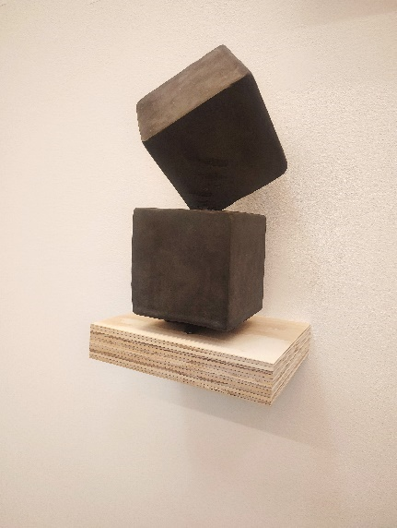
Elizabeth Laynez, Grade 10  Chicken, Shells, wood, rocks, and bone  Selected by Scout Hutchinson | 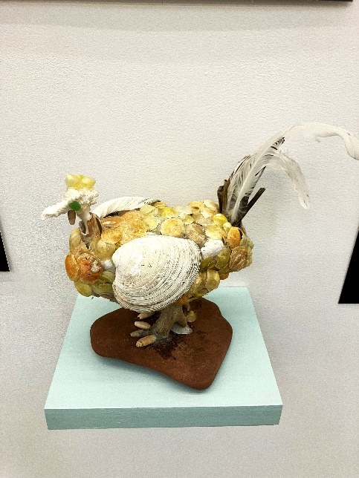

Center Moriches
Mateo Silva Villalon, Grade 11  Serene Citrus, Colored pencil on paper  Selected by Scout Hutchinson | 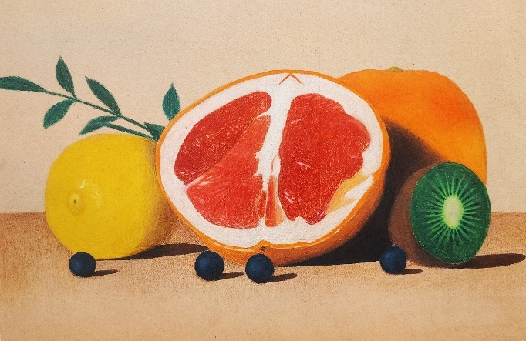

East Hampton High School
Sophie Riva, Grade 12  Rooftop, Digital photograph  Selected by Scout Hutchinson | 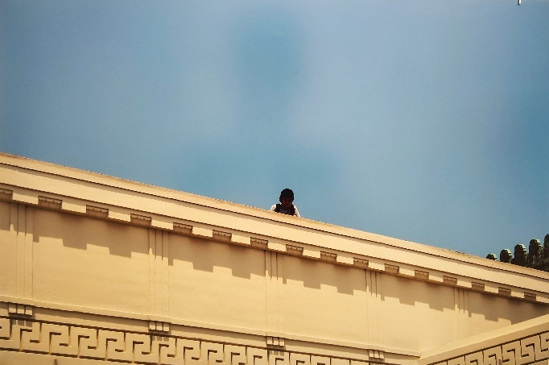
Amanda Barros-Ayala, Grade 12  Ami, Paper mache and cardboard  Selected by Scout Hutchinson | 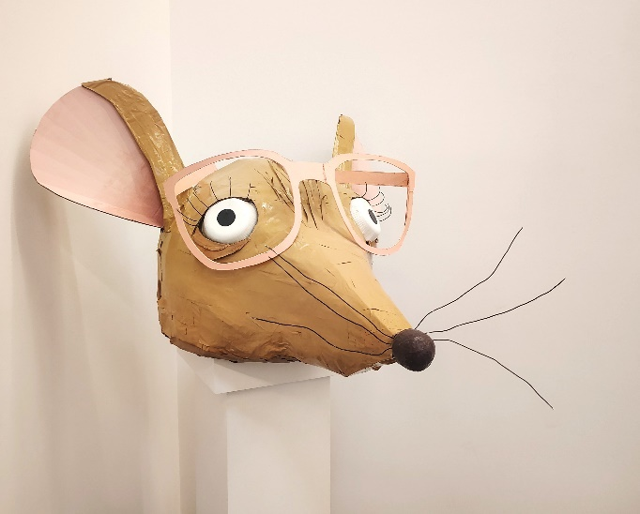
Morgan Lieder, Grade 12  Destination (Train Station), Acrylic on canvas  Selected by Scout Hutchinson | 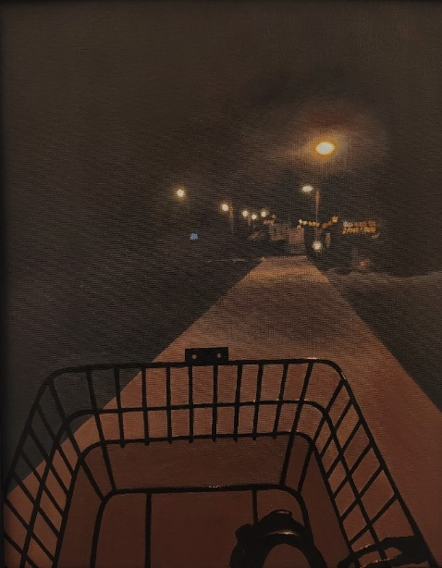

Gary D. Bixhorn Technical Center
Kim Lee, Grade 12  Cold Exposure, Digital photograph  Selected by Kaitlin Halloran | 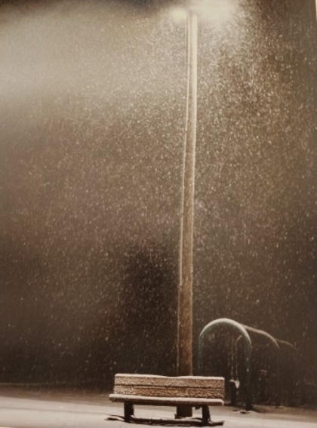
Ramion James, Grade 12  The Love of Vincent, Digital photograph  Selected by Scout Hutchinson | 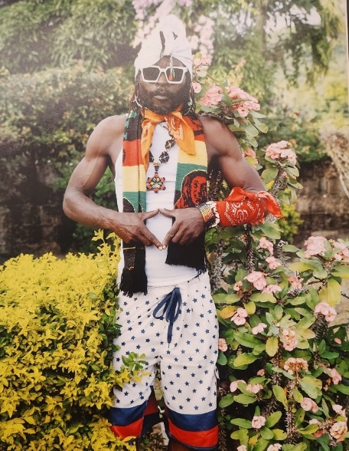
Heidi Lanze, Grade 12  Pretty In Pink, Digital photograph  Selected by Scout Hutchinson | 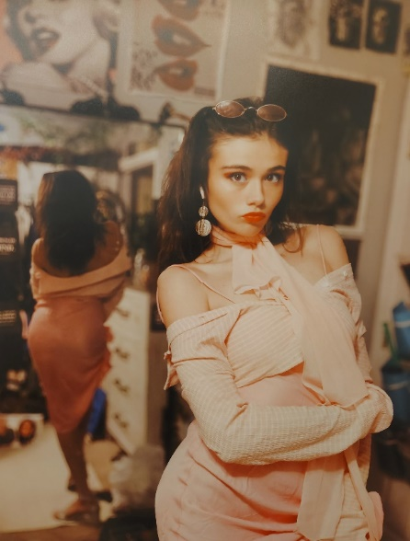
Dylan Undermark, Grade 11  Between Realities, Digital photograph  Selected by Scout Hutchinson | 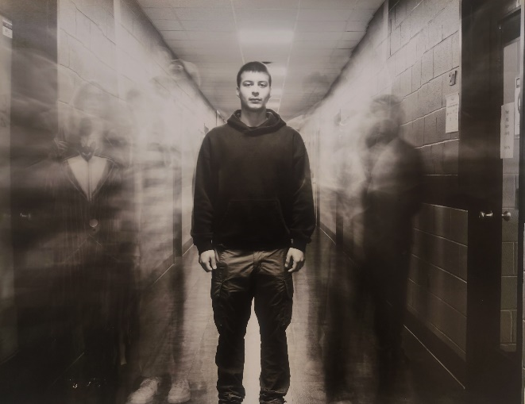
Julia Cruz, Grade 11  Convergence, Digital photograph  Selected by Kaitlin Halloran | 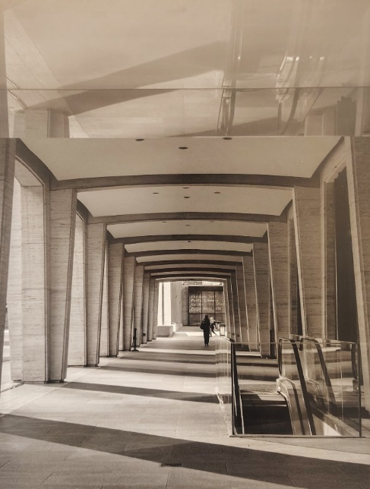

Miller Place
Samantha Selfridge, Grade 12  Clown Shoe, Pencil on paper  Selected by Kaitlin Halloran | 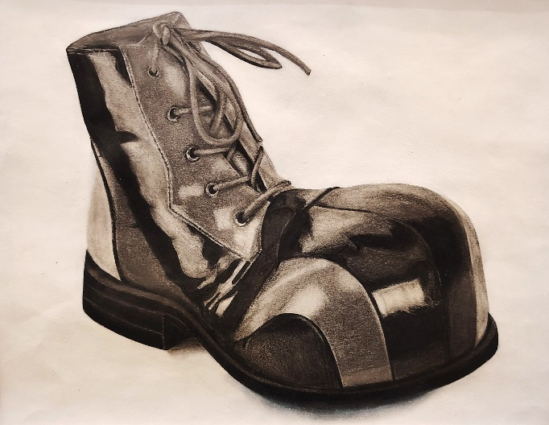
Amelia Avalos, Grade 11  Lux Street, Watercolor on paper  Selected by Kaitlin Halloran | 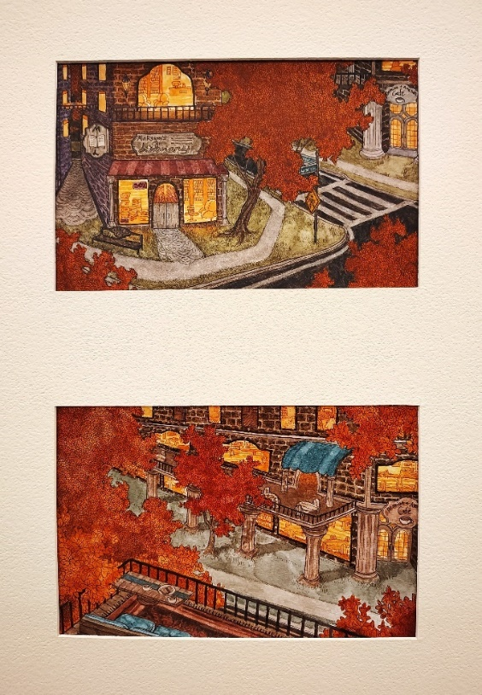

Ross School
Iris Mas de Melo Fernandes, Grade 12  Daydream, Acrylic on canvas  Selected by Scout Hutchinson | 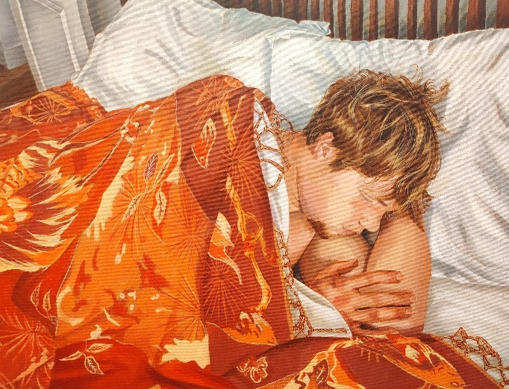
Rowan O'Brian, Grade 12  Iceland Landscape, Photograph  Selected by Kaitlin Halloran | 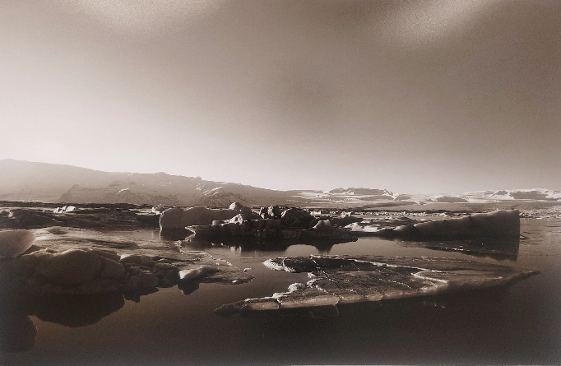

Gallery 3
Bellport High School
Evangeline Pacini, Grade 10  Portrait, Acrylic on canvas  Selected by Kaitlin Halloran | 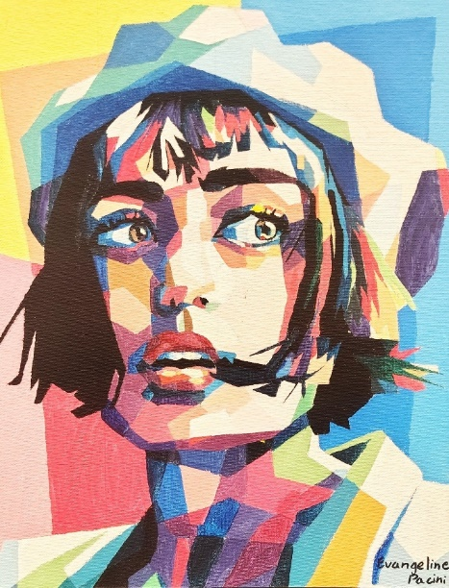

Eastport South Manor Junior Senior High School
Sara Mikula, Grade 12  Mellow Milo, Acrylic on canvas  Selected by Kaitlin Halloran | 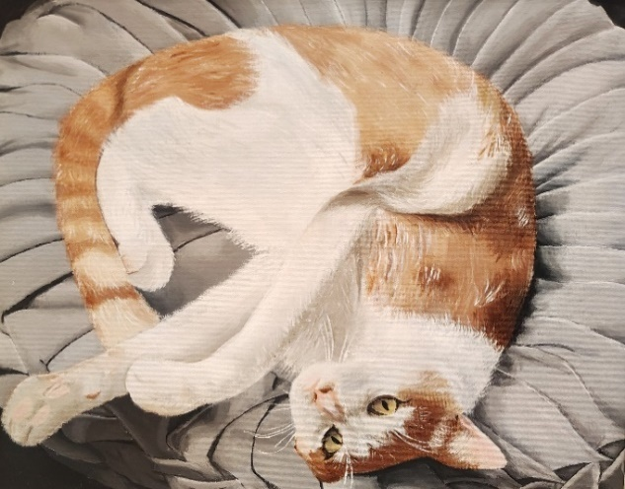
James Kreiling, Grade 12  The Ghost of the World's Fair, Photography  Selected by Kaitlin Halloran | 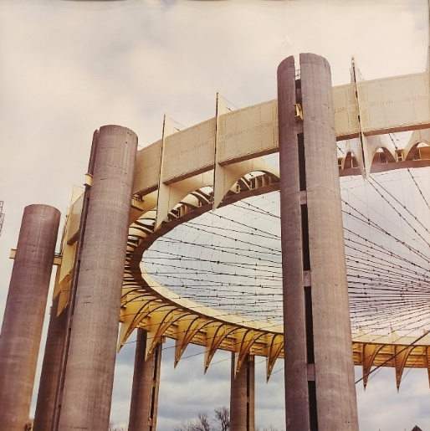
Westhampton Beach High School
Eleanor Greiner, Grade 11  Untitled, Colored pencil on paper  Selected by Scout Hutchinson | 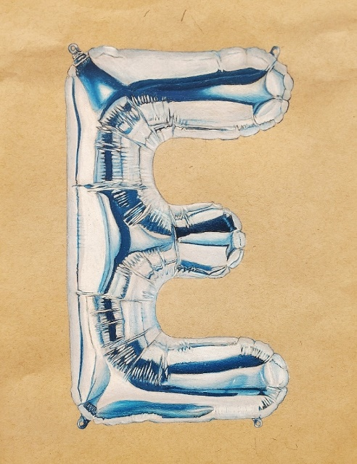

William Floyd
Catherine Corry, Grade 12  Untitled, Acrylic on canvas  Selected by Kaitlin Halloran | 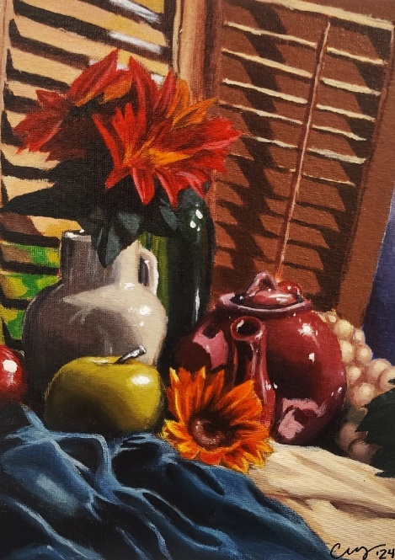
Gabriela Galan, Grade 12  Argentina, Colored pencil on paper  Selected by Scout Hutchinson | 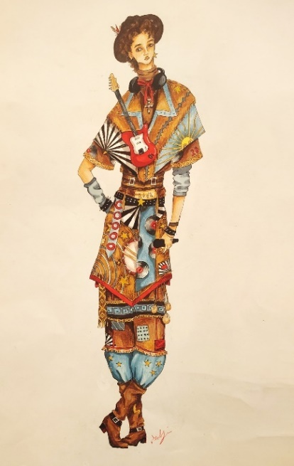

Pierson
Poppy Basseches, Grade 12  Untitled, Oil on wood  Selected by Kaitlin Halloran | 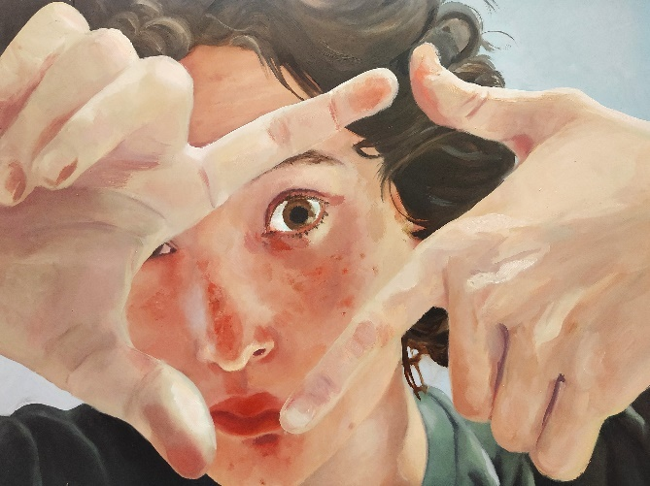
Elliot Schmidt, Grade 12  Untitled, Photograph  Selected by Kaitlin Halloran | 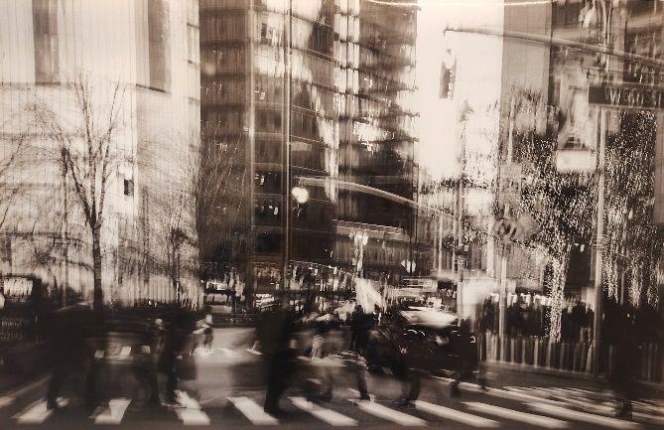
Patrick Henry, Grade 9  Untitled, Pencil on paper  Selected by Kaitlin Halloran | 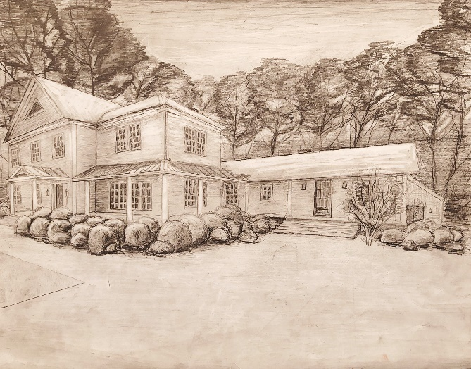

Shoreham Wading River
Vivian Shao, Grade 11  Untitled, Ceramic  Selected by Scout Hutchinson | 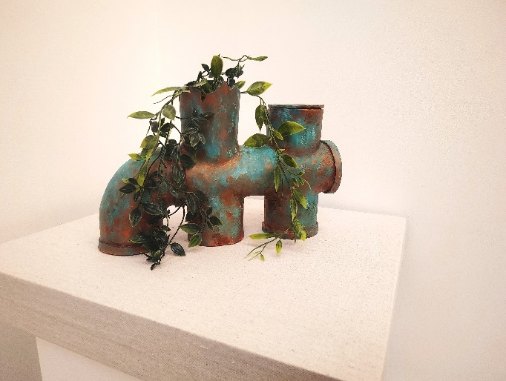

Hampton Bays High School
Ivanna Jara, Grade 10  Still Life, Photograph  Selected by Kaitlin Halloran | 