PARRISH ART MUSEUM
279 MONTAUK HIGHWAY, WATER MILL, NY 11976
T 631 283 2118 PARRISHART.ORG

FOR IMMEDIATE RELEASE
CONTACT: Susan Galardi 631-283-2118 x122 galardis@parrishart.org

PARRISH ART MUSEUM LAUNCHES THAW FEST—DANCE PARTY FEATURING DJ TWILO ON MARCH 22, AND SCREENING OF ‘KUSAMA: INFINITY,’ MARCH 24

The screening is presented in collaboration with Hamptons Doc Fest, as part of the Museum’s ‘The Artist’s Lens’ Series
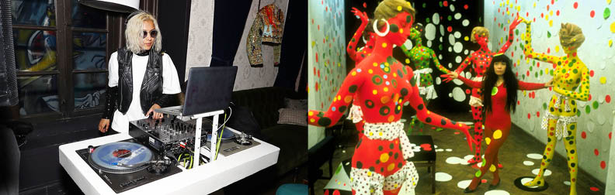
DJ Twilo. Photo: Courtesy of the artist; Film Still from Kusama—Infinity: The Life and Art of Yayoi Kusama. Photo: Copyright Harrie Verstappen

WATER MILL, NY 3/6/2019—To celebrate THAW FEST (The Hamptons Arts Weekend Festival) the Parrish Art Museum is presenting a dance party featuring DJ Twilo on Friday, March 22 and a screening of Kusama: Infinity on March 24. In addition, two new special exhibitions of photography—Renate Aller: The Space Between Memory and Expectation, and Jean-Luc Mylayne: A Matter of Place—will open at the Museum on March 24.

“I'm pleased that the Parrish is presenting a well-rounded program to celebrate the arts and culture of the Hamptons,” said Corinne Erni, Curator of Special Projects. “We hope a great number of community members, weekenders, and tourists young and old will take advantage of this special weekend to experience the Museum's rich programming.”

Dance Party with DJ Twilo
Friday, March 22, 7 – 9:30 pm
$12 | Free for Members, Children, and Students
The Parrish kicks off THAW Fest with a night of dancing and music in the Lichtenstein Theater with DJ TWILO. Drinks and special menu items will be available for purchase. DJ TWILO mixes a blend of house music, Top 40, the latest music from France, and hip-hop. Her ability to infuse her own musical sensibility into a varied archive has made her one of the most sought-after DJs on the east coast. TWILO has worked in recording studios for artists such as Beck, Bjork, Phillip Glass, Alicia Keys, and the techno producer Blackwatch; and has DJ’ed events including private parties, benefits, and art gallery openings (for the artist Banksy and others); and at venues including 1 Oak, Lincoln Center, Cipriani, Jue Lan Club, and Harlow East.
The Artist’s Lens: Kusama—Infinity
Screening, with a conversation by Terrie Sultan and John Torreano
Sunday, March 24, 2pm
$15 | $5 for Members, Children, and Students
Co-presented with Hamptons Doc Fest part of the Museum’s new series, The Artist’s Lens, the screening of Kusama—Infinity: The Life and Art of Yayoi Kusama (2018, NR, 80 minutes, Director: Heather Lenz) will be followed by a conversation with Sultan and artist Torreano. Now the top-selling female artist in the world, Kusama (Japanese, b. 1929) pushed boundaries that often alienated her from both her peers and those in power in the art world. The film follows the artist’s extraordinary trajectory from arriving in New York in 1957 to moving in avant-garde circles that included Donald Judd and Eva Hesse. A precursor to Pop Art, Kusama is often considered to have had a major influence on Andy Warhol. Her signature dot and net motifs led to Infinity Nets, hallucinatory paintings of loops and dots and physical representations of the idea of infinity.

Throughout his career, John Torreano has investigated the properties of real and fake gemstones and jewels—a metaphor for Vigil lights—in the differing contexts of lighting, placement, and materials. Following the screening, Sultan and Torreano will discuss Kusama, her work, and her artistic journey.

NEW EXHIBITIONS: On view Sunday, March 24 through July 28. (Full releases to follow).

RENATE ALLER
Renate Aller: The Space Between Memory and Expectation features 12 of the German photographer’s large-scale archival prints in a gallery installation specifically designed to present a compositionally unified environment. The immersive installation aligns seven photographs of dramatic ranges and peaks from her Mountain Interval series with five prints from Ocean | Desert—broad expanses of sea and sand. The viewer is surrounded by a panorama that smoothly transitions from mountains to ocean as the eye is guided from image to image along a compositionally coherent horizon line.

JEAN-LUC MYLAYNE
Jean-Luc Mylayne: A Matter of Place reveals the French-born photographer’s highly personal view of landscape and nature through monumentally scaled images from the Parrish permanent collection that illuminate the intimate bond between subject and photographer. Mylayne juxtaposes natural and man-made, stillness and motion, calm and tension within poetic and mysterious photographs of commonplace birds in natural habitats. The exhibition reveals the artist’s keen aptitude for observation, technical invention, and moral imperative for ecological harmony.

Friday nights are made possible, in part, by Presenting Sponsor, Bank of America. Additional support provided by The Corcoran Group and Sandy and Stephen Perlbinder.

About the Parrish Art Museum
Inspired by the natural setting and artistic life of Long Island’s East End, the Parrish Art Museum illuminates the creative process and how art and artists transform our experiences and understanding of the world and how we live in it. The Museum fosters connections among individuals, art, and artists through care and interpretation of the collection, presentation of exhibitions, publications, educational initiatives, programs, and artists-in-residence. The Parrish is a center for cultural engagement, an inspiration and destination for the region, the nation, and the world.

