**PARRISH ART MUSEUM**

**279 MONTAUK HIGHWAY, WATER MILL, NY 11976**

**T 631 283 2118     PARRISHART.ORG**

**FOR IMMEDIATE RELEASE**

**CONTACT:**Susan Galardi 631-283-2118 x122   [galardis@parrishart.org](https://remote.parrishart.org/owa/redir.aspx?C=DbGrSJkFXf3-i5U08lLUbmi1N6y08lSqJHGV8gaa1uVT4Hrh4j7UCA..&URL=mailto%3agalardis%40parrishart.org)

**DAVID SCOTT KASTAN DISCUSSES HIS NEW BOOK, “ON COLOR,” WITH ARTIST BYRON KIM AND PARRISH ART MUSEUM DIRECTOR TERRIE SULTAN**

**FRIDAY, APRIL 12, 6PM**

***A book signing follows the discussion, which addresses the concept of color from many varied viewpoints***

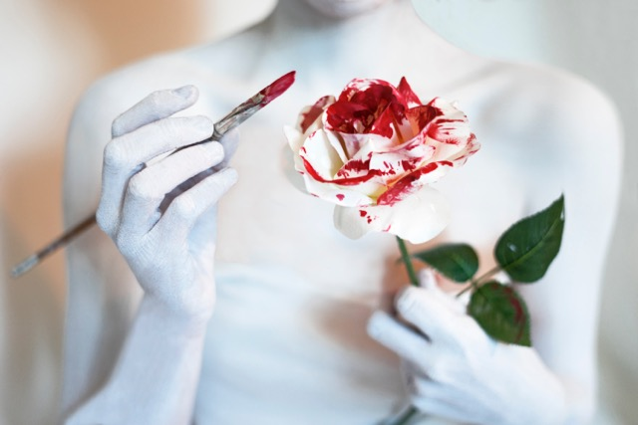

From the book *On Color*, Susannah Benjamin, *Roses are Red,* 2016

**WATER MILL, NY 3/27/2019**— Shakespeare scholar and author David Kastan will discuss his book, *On Color*, with artist Byron Kim and Parrish Art Museum Director Terrie Sultan, followed by a book signing on Friday, April 12, 6pm. *On Color*, the most recent project by the prolific author, is an investigation of color from myriad viewpoints.

“Color plays such an important role in our lives,” said Corinne Erni, Senior Curator of ArtsReach and Special Projects. “I much look forward to hearing these two accomplished thinkers and artists—Kastan and Kim—illuminate the many ways color affects us.”

Color, particularly on the East End of Long Island—an area renowned for the light that has attracted artists for generations—is a profound marker of our psychological and social existence. Kastan’s recent book, co-authored with Stephen Farthing, investigates color from literary, historical, cultural, anthropological, philosophical, art historical, political, and scientific perspectives. In 10 lively and wide-ranging chapters, each devoted to a specific color, Kastan and Farthing examine the various ways colors have shaped and continue to shape our social and moral imaginations. Each individual color becomes the focal point for a consideration of one of the extraordinary ways in which color appears and matters in our lives.

In his talk on April 12, moderated by Sultan, Kastan will explore the concepts and meaning of color with Kim, whose painting *Synecdoche*, a grid of hundreds of panels depicting human skin color, was included in the 1993 Whitney Biennial. Kastan will be available after the talk to sign copies of his book, available at the Museum shop.

**About David Scott Kastan**

David Scott Kastan, who previously taught at Columbia University and at Dartmouth College, is the George M. Bodman Professor of English at Yale University. He recently wrote the essay *Shaping Vision* for the catalogue that accompanies the Parrish Art Museum’s upcoming exhibition, *Thomas Joshua Cooper: Refuge* (May 5 through July 28). Kastan is one of the General Editors of the *Arden Shakespeare*, the co-editor of the *Bantam Shakespeare*, and the series editor of the *Barnes and Noble Shakespeare*. He has produced scholarly editions of Shakespeare’s *Henry IV, Part One, Milton’s Paradise Lost,* and *Marlowe’s Dr. Faustus*, and written widely on editing, textual theory, and early modern book history. His *A Will to Believe: Shakespeare and Religion* was published in 2014 by Oxford University Press and has just been reissued in paperback. Among his earlier books are *Shakespeare and the Shapes of Time, Shakespeare after Theory,* and *Shakespeare and the Book*. He also edited the essay collections, *A Companion to Shakespeare, Staging the Renaissance* (with Peter Stallybrass), and *The New History of Early English Drama* (with John Cox), as well as the five-volume *Oxford Encyclopedia of British Literature.*

**About Byron Kim**

Byron Kim is the Alex Katz Chair in Painting at the School of Art at The Cooper Union, and a Senior Critic at Yale School of Art. Kim often works in an area one might call the abstract sublime. His work sits at the threshold between abstraction and representation, between conceptualism and pure painting, revealing a charged space that often connects to the artist’s personal experiences in relation to larger cultural forces. Kim is best known for his painting, *Synecdoche*, an abstract painting in monochromes and a group portrait that was included in the 1993 Whitney Biennial. His ongoing series of *Sunday Paintings*, in which he records the appearance of the sky every week along with a diary entry, juxtaposes the cosmological with the quotidian. Among Kim’s numerous awards are the New York Foundation for the Arts Grant and the Louis Comfort Tiffany Foundation Award (1994), the National Endowment of the Arts Award (1995), the Alpert Award in the Arts (2008) and the Guggenheim Fellowship (2017).

Talk & Book Signing

**David Scott Kastan, On Color**

**Conversation with Kastan, Byron Kim, and Terrie Sultan**

Friday, April 12, 6:00pm

$12 | Free for Members, Children, and Students

Friday nights are made possible, in part, by Presenting Sponsor, Bank of America. Additional support provided by The Corcoran Group and Sandy and Stephen Perlbinder.  https://parrishart.org/sites/default/files/styles/thumbnail/public/BofA_rgb_6.png?itok=nllzEdGR

**About the Parrish Art Museum**

Inspired by the natural setting and artistic life of Long Island’s East End, the Parrish Art Museum illuminates the creative process and how art and artists transform our experiences and understanding of the world and how we live in it. The Museum fosters connections among individuals, art, and artists through care and interpretation of the collection, presentation of exhibitions, publications, educational initiatives, programs, and artists-in residence. The Parrish is a center for cultural engagement, an inspiration and destination for the region, the nation, and the world.