PARRISH ART MUSEUM
279 MONTAUK HIGHWAY, WATER MILL, NY 11976
T 631 283 2118 PARRISHART.ORG

FOR IMMEDIATE RELEASE
CONTACT: Susan Galardi 631-283-2118 x122 galardis@parrishart.org

ARTIST BASTIENNE SCHMIDT DISCUSSES HER NEW MONOGRAPH, GRIDS AND THREADS, WITH PARRISH ART MUSEUM DIRECTOR TERRIE SULTAN
FRIDAY, MARCH 29, 6PM

A book signing follows the discussion
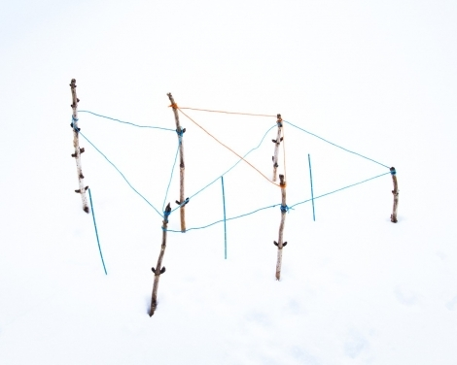
Image from the monograph Grids and Threads, Bastienne Schmidt, courtesy of the artist

WATER MILL, NY 3/15/2019— Parrish Art Museum collection artist and photographer Bastienne Schmidt will discuss her new, fully illustrated monograph, Grids and Threads, with Museum Director Terrie Sultan, followed by a book signing on Friday, March 29, 6pm at the Museum. A minimalist meditation on the concept of white space and its perception that documents Schmidt’s most recent project, Grids and Threads opens with an interview of the artist by Sultan and an essay by arts writer Jacoba Urist.

“I’m very excited to feature Bastienne Schmidt, whose work is a poetic meditation on shape, color, and space, and allows us to connect to art emotionally,” said Corinne Erni, Senior Curator of ArtsReach and Special Projects.

Presented in two sections, Grids and Threads (2018, jovis Verlag GmbH) is inspired by artist Marcel Duchamp’s 1913 work, Three Standard Stoppages, in which he playfully reconceived a standard unit of measure—a meter—to underscore the randomness of qualification or quantification. Part one of Grids and Threads addresses this through 36 bird’s-eye-view photographs of constructed installations placed in the snow. Schmidt used stakes and cotton thread in blue and orange to create new imaginary spaces. While some were quite small and others much larger, the photographs make it impossible to gauge the scale.

Through 40 photographs, Part Two documents mixed media works on Arches paper, where punched grid of 8 x 8 inches is divided into one-square-inch spaces that draw light and shadow onto the white paper. The idea of creating a series of never-ending variation of white squares in a reductive process is related to the practice of artists Agnes Marin and Robert Ryman. The square grid in white is a quiet reflection on the concept of a minimal space; the variations, of what happens inside of the squares, play with the thought of absolute freedom and absolute constraint.

About Bastienne Schmidt
Bastienne Schmidt is a German born, Bridgehampton and New York based multimedia artist who has lived and worked for many years in Greece and Italy. As an artist, she explores concepts of identity and place through photography and painting. Her work has been collected by the Museum of Modern Art, the Brooklyn Museum, the International Center of Photography, and the Victoria and Albert Museum in London, among many others. Her work has been exhibited in over one hundred exhibitions around the world and she was recently the recipient of the Watermill Center Residency and Parrish Art Museum Residency. Grids and Threads is Schmidt’s seventh monograph.

Talk & Book Signing
Grids and Threads, Bastienne Schmidt in Conversation with Terrie Sultan
Friday, March 29, 6:00pm
$12 | Free for Members, Children, and Students

Friday nights are made possible, in part, by Presenting Sponsor, Bank of America. Additional support provided by The Corcoran Group and Sandy and Stephen Perlbinder.

About the Parrish Art Museum
Inspired by the natural setting and artistic life of Long Island’s East End, the Parrish Art Museum illuminates the creative process and how art and artists transform our experiences and understanding of the world and how we live in it. The Museum fosters connections among individuals, art, and artists through care and interpretation of the collection, presentation of exhibitions, publications, educational initiatives, programs, and artists-in residence. The Parrish is a center for cultural engagement, an inspiration and destination for the region, the nation, and the world.

