PARRISH ART MUSEUM
279 MONTAUK HIGHWAY, WATER MILL, NY 11976
T 631 283 2118 PARRISHART.ORG

FOR IMMEDIATE RELEASE
CONTACT: Susan Galardi 631-283-2118 x122 galardis@parrishart.org

PARRISH ART MUSEUM DIRECTOR TERRIE SULTAN, ARTIST YIGAL OZERI, AND PHOTOREALISM EXPERT LOUIS K. MEISEL DISCUSS THE THEMES AND ARTISTS OF PHOTOREALISM FRIDAY, FEBRUARY 1, 6PM

The three will lead a gallery discussion, based on the Photorealist paintings in the exhibition currently on view, from their unique perspectives

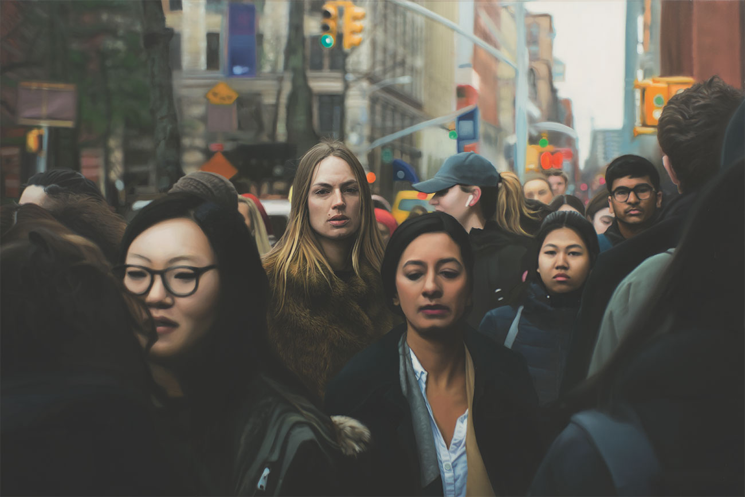
Yigal Ozeri (Israeli, born 1958) Untitled; Zuzanna, 2018. Oil on canvas, 48 x 72 inches
WATER MILL, NY 1/24/2019—The artists and themes of the Photorealist movement will be illuminated in a gallery talk at the Parrish Art Museum on Friday, February 8, at 6pm. Museum Director Terrie Sultan, Photorealist artist Yigal Ozeri, whose work is currently on view, and Louis K. Meisel, Photorealism expert who coined the term in 1969, will lead the conversation. The event will take place in the Museum’s gallery that features Photorealist works as part of the reinstallation of the Museum’s permanent collection, Every Picture Tells a Story. Reservations are required, as seating is limited.

“This will be a stimulating 360 look at Photorealism, from the points of view of an artist, a collector, and a museum director, while surrounded by the actual works in the gallery space,” said Corinne Erni, Senior Curator of ArtsReach and Special Projects.

From its beginnings in California and New York in the late 1960s, Photorealism was denounced as a fad in reaction to Pop, Minimalism, Land Art, and Performance Art. It gained recognition in the 1970s and continued to prompt exploration through the decades as contemporary artists returned to representation as valid and valuable. A 2017 exhibition at the Parrish, From Lens to Eye to Hand, demonstrated that the movement remains undiluted, conceptually coherent, and consistently compelling.

Photorealists often reimagine traditional painting genres, such as landscape, still life, and portraiture.
In the Museum’s current exhibition, depictions of the urban landscape such as the new acquisition Morning Walk, Hampstead High Street (2011) by Tom Blackwell, and Richard Estes’s The Plaza (1995) take advantage of the fact that a photograph can fix details in a scene that the eye doesn’t usually see, like reflections, or a perspective skewed by a moving vehicle. The human body, in action or at rest, is also a central Photorealist theme, as seen in Ron Kleeman’s Red Bull Sitting (2011) and Ozeri’s Untitled; Zuzanna (2018). Conveying both photographic flatness and physical dimensionality, the jam-packed compositions of these new acquisitions draw us into narrative possibilities while reminding us that there are many ways to see the world.

Friday, February 8, 6pm
GALLERY TALK: PHOTOREALISM
Parrish Art Museum Director Terrie Sultan, artist Yigal Ozeri,
and Photorealism expert Louis K. Meisel
$12 | Free for Members, Children, and Students
Space is limited; reservations required.

Friday nights are made possible, in part, by the generous support of The Corcoran Group, and Sandy and Stephen Perlbinder.

About the Parrish Art Museum
Inspired by the natural setting and artistic life of Long Island’s East End, the Parrish Art Museum illuminates the creative process and how art and artists transform our experiences and understanding of the world and how we live in it. The Museum fosters connections among individuals, art, and artists through care and interpretation of the collection, presentation of exhibitions, publications, educational initiatives, programs, and artists-in residence. The Parrish is a center for cultural engagement, an inspiration and destination for the region, the nation, and the world.

