PARRISH ART MUSEUM
279 MONTAUK HIGHWAY, WATER MILL, NY 11976
T 631 283 2118 PARRISHART.ORG

FOR IMMEDIATE RELEASE
CONTACT: Susan Galardi 631-283-2118 x122 galardis@parrishart.org

RABBI DAVID WHIMAN AND PARRISH ART MUSEUM DIRECTOR
TERRIE SULTAN DISCUSS THE BIBLICAL NARRATIVES OF DAVID SALLE’S PAINTINGS AND THEIR RELEVANCE TODAY. FRIDAY, FEBRUARY 1, 6PM

“After Michelangelo,” Salle’s large-scale paintings inspired by the Sistine Chapel, upend the original source material with images referencing contemporary events

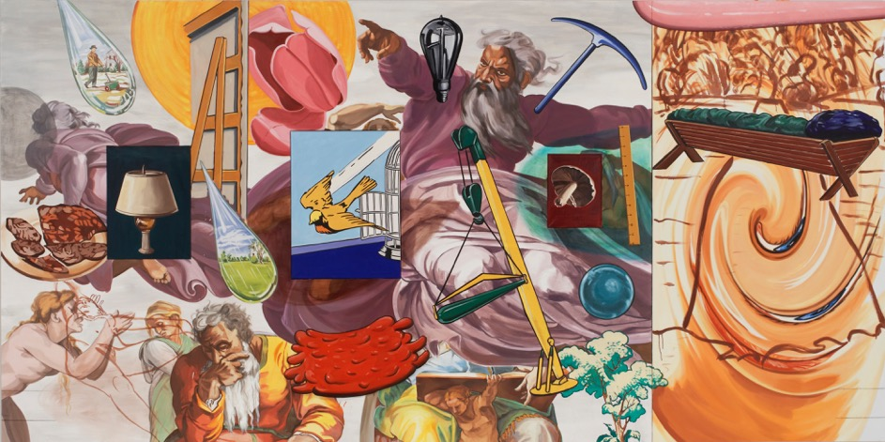
David Salle (American, b. 1952), After Michelangelo, The Creation, 2005–2006. Oil and acrylic on linen, 90 x 180 in.

WATER MILL, NY 1/17/2019—The Parrish Art Museum presents Rabbi David Whiman and Museum Director Terrie Sultan and in an in-depth gallery talk on David Salle’s large-scale paintings, After Michelangelo (2005–2006), inspired by the Sistine Chapel, on February 1 at 6 pm. The paintings—The Creation, The Flood, and The Last Judgment—never-before-seen in the United States, are on view in the Museum’s permanent collection exhibition Every Picture Tells a Story. Rabbi Whiman teaches a course entitled The Bible as Literature at Sag Harbor’s John Jermain Memorial Library that examines sections of the Pentateuch (the first five books of the Hebrew Bible/Old Testament) from an exclusively literary perspective of content, style, narrative technique, and intent. His conversation with Sultan at the Parrish will focus on the Biblical narratives depicted in Salle’s paintings and the artist’s contemporary interpretation.

“I’m excited to invite Rabbi Whiman for a unique perspective on David Salle’s epic works,” said Corinne Erni, Senior Curator of ArtsReach and Special Projects. “Whiman’s literary approach to understanding Biblical stories in today’s times—the basis of Salle’s paintings—will be a fascinating experience.”

After Michelangelo, created by Salle between 2005 and 2006 in East Hampton, New York, was commissioned in 2004 by collector Carlo Bilotti for his museum in Rome’s Borghese Gardens. Recognizing Salle’s decades-long ties to the East End of Long Island, Bilotti’s widow Margaret S. Bilotti gifted the works to the Parrish. The themes for the cycle of paintings, determined by Salle and Bilotti in a unique collaboration of patron and artist, prompted the artist’s response to the material as it relates to contemporary events and recent history.

In The Flood, Salle updated the biblical story of the deluge from the Book of Genesis with references to natural disasters such as the 2004 Asian tsunami and Hurricane Katrina. The Creation, dominated by the god figure in The Creation of Adam, includes references to human ingenuity and new beginnings, with imagery of an industrial light bulb, tools, and machines. In The Last Judgement, figures from Michelangelo’s fresco on the Sistine Chapel altar wall are overtaken by images of doom and destruction: missiles, Satan, and a scythe-wielding personification of death.

Friday, February 1, 6pm
GALLERY TALK: AFTER MICHELANGO
Parrish Art Museum Director Terrie Sultan and
Rabbi David Whiman Discuss David Salle’s Paintings
$12 | Free for Members, Children, and Students
Space is limited, advance reservations required.

Friday nights are made possible, in part, by the generous support of Bank of America, The Corcoran Group, and Sandy and Stephen Perlbinder.

About the Parrish Art Museum
Inspired by the natural setting and artistic life of Long Island’s East End, the Parrish Art Museum illuminates the creative process and how art and artists transform our experiences and understanding of the world and how we live in it. The Museum fosters connections among individuals, art, and artists through care and interpretation of the collection, presentation of exhibitions, publications, educational initiatives, programs, and artists-in residence. The Parrish is a center for cultural engagement, an inspiration and destination for the region, the nation, and the world.

