PARRISH ART MUSEUM
279 MONTAUK HIGHWAY, WATER MILL, NY 11976
T 631 283 2118 PARRISHART.ORG

FOR IMMEDIATE RELEASE
CONTACT: Susan Galardi 631-283-2118 x122 galardis@parrishart.org

CONNECTIONS BETWEEN ARTIST WILLIAM MERRIT CHASE AND THE SHINNECOCK NATION REVEALED IN A TALK BY CHIEF CURATOR ALICIA G. LONGWELL AND GUEST CURATOR DAVID BUNN MARTINE. FRIDAY, JANUARY 25, 6PM

The Curator’s View talk references the exhibition “The Shinnecock Years,” featuring paintings by Chase and his students and archival images of the Shinnecock

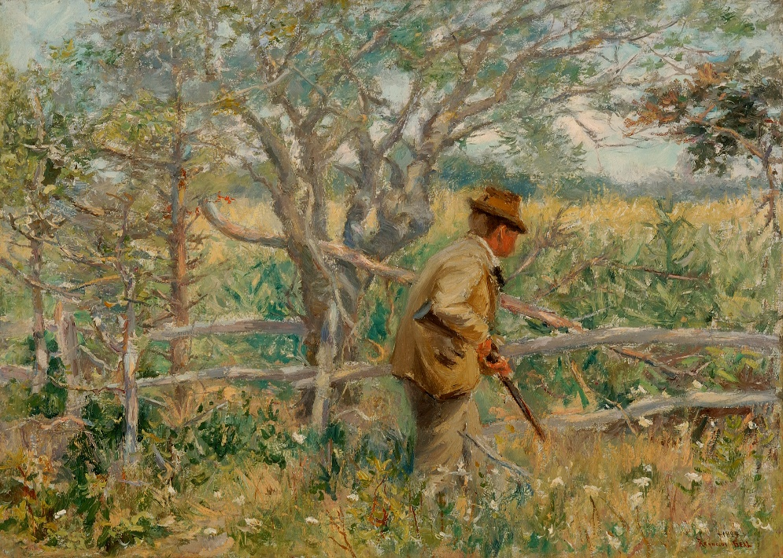
Reynolds Beal (1867-1951), Captain Harlow’s Lot, Southampton, 1894.
Gift of Stephane Samuel and Robert M. Rubin

WATER MILL, NY 1/9/2019—The special connections and ongoing relationships between artist William Merritt Chase, his family and students, and members of the Shinnecock Nation beginning in the late 1800s is revealed in an illustrated talk by Alicia G. Longwell, Ph.D., The Lewis B. and Dorothy Cullman Chief Curator at the Museum, and guest curator/Shinnecock historian David Bunn Martine on Friday, January 25 at 6pm. Longwell and Martine’s discussion is based on the exhibition William Merritt Chase: The Shinnecock Years, currently on view at the Parrish. The exhibition presents six paintings, dating from 1894 to 1900, of iconic scenes from the area, and detailed wall texts illustrated with archival images, from both the Parrish’s William Merritt Chase Archives and from Martine’s family collection, depicting the confluence of the two communities.

“This exhibition has given us a wonderful opportunity to shed light on a history that has been little considered in the story of William Merritt Chase’s years in the Shinnecock Hills,” said Longwell.

William Merritt Chase (1849–1916) first came to Southampton in 1891 as the founding director of the Shinnecock Hills Summer School of Art, and he and his family spent summers in Shinnecock for the next 25 years. Mrs. Chase began to record these summers in photographs taken with her Kodak box camera and printed in blue-toned cyanotype. The largely unknown history of that time reveals the bonds that grew among Chase, other “summer colonists,” and the people of the Reservation. These relationships had a personal impact on the Chase family. In a tribute to their neighbors, the Chases gave their fourth daughter Hazel, born in Southampton, the middle name “Neamaug”—a Shinnecock word meaning “between the waters.” Students from the Shinnecock Hills Summer School of Art also, for a fee, were permitted to set up their easels on the pristine Reservation lands.

Mrs. Chase and the community relied on these neighbors for everything from food to domestic support—many of the women on the Reservation were skilled seamstresses and laundresses. In their abundant market gardens, the Shinnecock grew produce to sell to the summer community, along with eggs, broiler chickens, and Muscovy ducks. Martine remembers his grandmother Alice Martinez recalling, “We canned a lot of vegetables. And Father [Charles Bunn, David Bunn Martine’s great-grandfather] used to store cabbage in the basement in sand.”

The Shinnecock were also a part of the summer colonists’ leisure activities. Men from the Reservation built the Shinnecock Hills golf course—as depicted in an image dated around 1900. Others, well known for hunting and fishing skill, were sought after guides. This association is revealed in a copy of Bunn’s advertisement for “Instruction of Young Boys in Handling Firearms;” in Chase’s painting The Pot Hunter, ca. 1894; and the hunting scene Captain Harlow’s Lot, Southampton, 1894, by his student Reynolds Beal (American, 1867-1951).

About David Bunn Martine
David Bunn Martine, born David Bunn Siklos in 1960 in Southampton, is of Shinnecock/Montauk, Chiricahua Fort Sill Apache from his mother Marjorie, a classically trained opera and concert singer. His father, Thomas Siklos is a Hungarian music director, organist and voice teacher. In 2013 Martine completed on an oral history book of his family through four verbatum oral histories from both the Native American and Hungarian heritage. Time and Memories, Histories and Stories of a Shinnecock-Apache-Hungarian Family, Compiled and Edited by David Bunn Martine, contains oral histories from David's grandmother, Alice Osceola Bunn Martinez; uncle, David Walkus Martinez; mother, Marjorie Carola Martinez; and father, Thomas Siklos. Martine, a painter and sculptor, is currently Director/Curator of the Shinnecock Nation Cultural Center and Museum, Shinnecock Reservation, Southampton, NY; Chairperson of American Indian Artists Inc. (AMERINDA) based in New York City. He holds degrees and certificates in Art Education, Design, and Museum Studies.

About Alicia Longwell
At the Parrish Art Museum, Alicia Longwell has pursued a special interest in the history of the art and artists of Eastern Long Island. She has organized numerous survey exhibitions, including Malcolm Morley: Painting, Paper, Process (2012), Dorothea Rockburne: In My Mind’s Eye (2011), Sand: Memory, Meaning and Metaphor (2008); and North Fork/South Fork: East End Art Now (2004) and has curated solo exhibitions on the work of artists Barbara Bloom, Marsden Hartley, Frederick Kiesler, Alan Shields, Esteban Vicente, and Jack Youngerman, among others. Longwell has authored many publications for the Parrish including Jane Freilicher and Jane Wilson: Seen and Unseen (2015); William Glackens (2014, contributing essay); William Merritt Chase in the Collection of the Parrish Art Museum, 2014; Angels, Demons, and Savages: Pollock, Ossorio, Dubuffet (2013; contributing essay), and many others Longwell received her Ph.D. degree from the Graduate Center, City University of New York, where her dissertation topic was John Graham, the subject of a critically acclaimed retrospective she organized for the Parrish Art Museum in 2017.

Friday nights are made possible, in part, by the generous support of The Corcoran Group, BNB Bank, and Sandy and Stephen Perlbinder.

THE CURATOR’S VIEW:
Alicia Longwell and David Bunn Martine on
William Merritt Chase: The Shinnecock Years
Friday, January 25, 6pm
$12, free for Members, children, and students; includes Museum admission

About the Parrish Art Museum
Inspired by the natural setting and artistic life of Long Island’s East End, the Parrish Art Museum illuminates the creative process and how art and artists transform our experiences and understanding of the world and how we live in it. The Museum fosters connections among individuals, art, and artists through care and interpretation of the collection, presentation of exhibitions, publications, educational initiatives, programs, and artists-in-residence. The Parrish is a center for cultural engagement, an inspiration and destination for the region, the nation, and the world.
###

