PARRISH ART MUSEUM
279 MONTAUK HIGHWAY, WATER MILL, NY 11976
T 631 283 2118 PARRISHART.ORG

FOR IMMEDIATE RELEASE
CONTACT: Susan Galardi 631-283-2118 x122 galardis@parrishart.org

THE PARRISH SCREENS “HOME”— SANDY PERLBINDER’S SATIRIC SHORT FILM ON THE ARCHITECT/CLIENT RELATIONSHIP, FOLLOWED BY A PANEL WITH ARCHITECTURE CRITIC PAUL GOLDBERGER, FRIDAY, APRIL 5, 6PM

This “Inter-Sections: The Architect in Conversation” program includes architect James Merrell, psychoanalyst Robby Stein, and Parrish Director Terrie Sultan

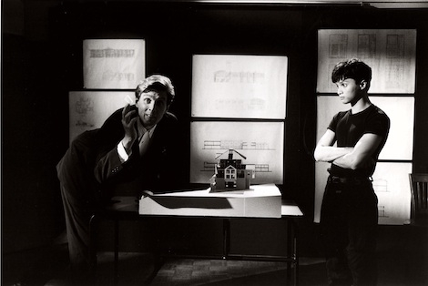
Film still from Home. Photo: Courtesy of Sandy Perlbinder

WATER MILL, NY 3/21/19—The Parrish Art Museum will screen Home, a satiric short film by Sandy Perlbinder that provides an insightful, hilarious view of an imposing architect stereotype and his naïve clients, on Friday, April 5, at 6pm. The screening of the film, which was a featured short at The Sundance Film Festival, will be followed by a panel discussion with Perlbinder, architecture critic Paul Goldberger, architect James Merrell, and psychoanalyst Robby Stein, moderated by Museum Director Terrie Sultan. The event is part of the Museum’s series Intersections: The Architect in Conversation.

“I’m excited to screen this pointed film and examine the myth of the contemporary starchitect and the psychology behind the expectations and aspirations of people who have their homes designed,” said Corinne Erni, Curator of Special Projects and ArtsReach.
Home (1989, NR, 7:40 minutes), directed by Perlbinder, a filmmaker/producer based in New York and the Hamptons, tells the story of a tyrannical starchitect who imposes his absurd vision on an unsuspecting couple building their first home. John Glover stars as Erich Hochmann, a brilliant and trendy deconstructivist architect modeled after Peter Eisenman, whose arrogance extends beyond his students and associates to his well-heeled, social-climbing clients. The protagonist also references personalities such as Howard Roark from Ayn Rand’s The Fountainhead, and Frank Lloyd Wright.

After a short stint learning the ropes in commercial TV production, Sandy Perlbinder started her own company producing award-winning commercials and films. Home, her first comedy/drama, grew out of Perlbinder’s own experiences enduring construction and renovation while living through the tyranny of a starchitect. Funny and smart, Home provides a springboard for a broad analysis of the relationship between a specific type of architect and his clients by a multi-disciplinary panel of experts in fields ranging from architecture to psychoanalysis.

Paul Goldberger, who won the Pulitzer Prize for Distinguished Criticism, is a contributing editor at Vanity Fair and was the architecture critic for The New Yorker from 1997-2011. He also wrote on the topic for Architectural Digest, and for decades at The New York Times. Architect James Merrell, who studied under Peter Eisenman and leads his own firm in Sag Harbor, has more than 30 years of experience designing residences on the East End and West Coast. Dr. Robert Stein is a Sag Harbor based psychoanalyst/couples and family therapist who has practiced for 40 years, and a three time appointee to the Sag Harbor Village Board.

Film & Talk
“Home” by Sandy Perlbinder, followed by a panel discussion
Part of Intersections: The Architect in Conversation
Friday, April 5, 6pm
1989, NR, 7:40 minutes
Sandy Perlbinder, Director
$12 | Free for Members and Students

Friday nights are made possible, in part, by Presenting Sponsor, Bank of America. Additional support provided by The Corcoran Group and Sandy and Stephen Perlbinder.

About the Parrish Art Museum
Inspired by the natural setting and artistic life of Long Island’s East End, the Parrish Art Museum illuminates the creative process and how art and artists transform our experiences and understanding of the world and how we live in it. The Museum fosters connections among individuals, art, and artists through care and interpretation of the collection, presentation of exhibitions, publications, educational initiatives, programs, and artists-in residence. The Parrish is a center for cultural engagement, an inspiration and destination for the region, the nation, and the world.

