PARRISH ART MUSEUM
279 MONTAUK HIGHWAY, WATER MILL, NY 11976
T 631 283 2118 PARRISHART.ORG

FOR IMMEDIATE RELEASE
CONTACT: Susan Galardi 631-283-2118 x122 galardis@parrishart.org

PARRISH ART MUSEUM SCREENS “PAINTERS PAINTING: A CANDID HISTORY OF THE NEW YORK ART SCENE, 1940-1970,” FOLLOWED BY TALK WITH PAINTER VALERIE JAUDON AND MUSEUM DIRECTOR TERRIE SULTAN

The screening, on Friday, January 18, 6pm, is co-presented
with Hamptons Doc Fest and part of the Museum’s The Artist’s Lens series
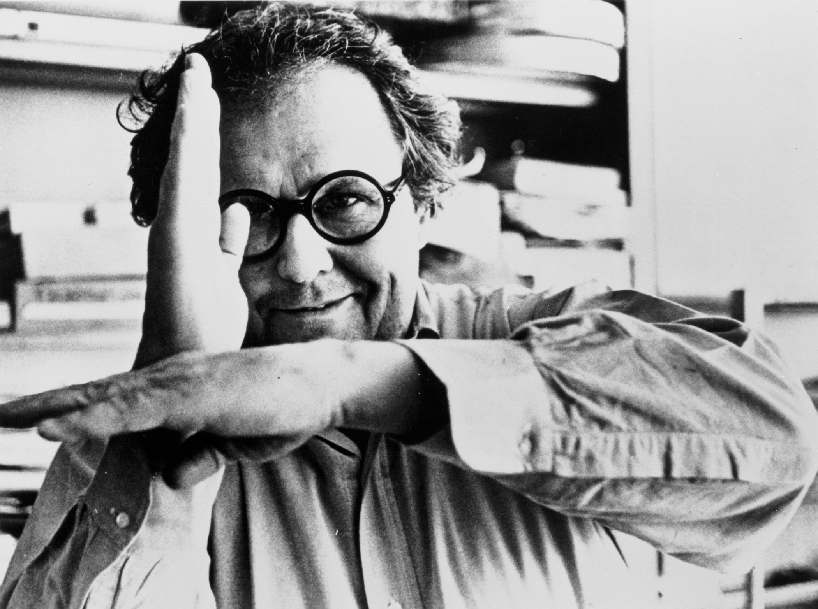
Painters Painting Director Emile de Antonio

WATER MILL, NY 1/4/2019—The Parrish Art Museum screens Painters Painting: A Candid History of the New York Art Scene, 1940-1970 (1973, NR, 116 minutes)—an insider’s view of one of the most innovative periods of American art, from Abstract Expressionism to Pop–—on Friday, January 18, at 6pm. In the film, Director Emile de Antonio conducts candid, intimate interviews with artists in their studios including Willem de Kooning, Jasper Johns, Andy Warhol, Robert Rauschenberg, Helen Frankenthaler, Frank Stella, Hans Hofmann, and Robert Motherwell; and talks with the powerbrokers of the art world at that time such as dealer Leo Castelli. Co-presented with Hamptons Doc Fest and the first program in the Museum’s new series The Artist’s Lens, the screening will be followed by a talk with painter Valerie Jaudon and Parrish Director Terrie Sultan, both of whom knew many of the subjects of the film.

“This film captures an immensely important moment of change in American art, and the candid interviews with all these great artists before they were famous are priceless,” said Corinne Erni, Curator of Special Projects.
Emile de Antonio was a keen observer of the art world and important conduit between artist friends with gallerists. In addition to providing a comprehensive survey of the New York art scene through the artists who shaped it, Painters Painting offers a glimpse into another side of that world through interviews with collectors, curators, dealers, and critics including Hilton Kramer and Clement Greenberg. Combining interviews with live footage of the artists at work in their studio, de Antonio and cinematographer Ed Emshwiller created a groundbreaking work that captured major contemporary art movements in a way no film maker had ever before. In an interview for the online journal Senses of Cinema, de Antonio said, "I was probably the only filmmaker in the world who could [have made Painters Painting] because I knew all those people, from the time that they were poor, and unsuccessful and had no money. I knew Warhol and Rauschenberg and Jasper Johns and Stella before they ever sold a painting, and so it was interesting to [do the film about them]."

About Valerie Jaudon
During the course of her 40-year career, Valerie Jaudon has been committed to redefining the parameters of abstraction. A member of the original Pattern and Decoration group, she is a representative of important tendencies of the larger Postminimalist movement. Jaudon was the driving force behind the influential 1991 Sidney Janis Gallery exhibition, Conceptual Abstraction and has continued to work toward the development of a grammar of abstraction. Jaudon is the recipient of numerous awards and grants and her work has been collected by and exhibited in major museums including The Museum of Modern Art and the Whitney Museum of American Art, New York; the Hirshhorn Museum and Sculpture Garden and the National Gallery, Washington DC; Art Institute of Chicago; and others.
SCREENING AND TALK
Painters Painting: A Candid History of the New York Art Scene, 1940-1970
1973, NR, 116 minutes
Director: Emile de Antonio; Cinematography: Ed Emshwiller;
Followed by a conversation with Valerie Jaudon and Terrie Sultan
Co-presented with Hamptons Doc Fest
Part of The Artist’s Lens series at the Parrish Art Museum

Friday, January 18, 6:00pm
$20 | $5 for Members and Students

Friday nights are made possible, in part, by the generous support of The Corcoran GroupBNB Bank, and Sandy and Stephen Perlbinder.

About the Parrish Art Museum
Inspired by the natural setting and artistic life of Long Island’s East End, the Parrish Art Museum illuminates the creative process and how art and artists transform our experiences and understanding of the world and how we live in it. The Museum fosters connections among individuals, art, and artists through care and interpretation of the collection, presentation of exhibitions, publications, educational initiatives, programs, and artists-in-residence. The Parrish is a center for cultural engagement, an inspiration and destination for the region, the nation, and the world.

