PARRISH ART MUSEUM
279 MONTAUK HIGHWAY, WATER MILL, NY 11976
T 631 283 2118 PARRISHART.ORG

FOR IMMEDIATE RELEASE
CONTACT: Susan Galardi 631-283-2118 x122 galardis@parrishart.org

“BASQUIAT: RAGE TO RICHES”—THE NO-HOLDS-BARRED STORY OF THE SEMINAL ARTIST TOLD THROUGH THOSE CLOSEST TO HIM—
SCREENED AT THE PARRISH ART MUSEUM ON FRIDAY, FEBRUARY 22, 6PM

Screening is followed by a talk with Michael Halsband, who knew and photographed the artist, and Parrish Curator Corinne Erni

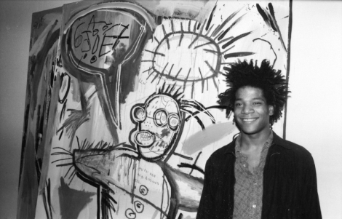
Film Still from American Masters—Basquiat: Rage to Riches. Photo: Marion Busch

WATER MILL, NY 2/8/2019—On Friday, February 22, at 6pm, the Parrish Art Museum will screen American Masters—Basquiat: Rage to Riches (2017, NR, 90 minutes), a candid telling of the life of Jean-Michel Basquiat(American, 1960 –1988), one of the most influential American artists of the 20th century, by family, friends, lovers, and art dealers that exposes the money, drugs, and racism that followed him. Part of The Artist’s Lens series at the Parrish and to recognize Black History Month, the screening is co-presented with Hamptons Doc Fest, and will be followed by a talk with Michael Halsband, who befriended and photographed the artist, and Corinne Erni, Senior Curator of ArtsReach and Special Projects.

“The film digs deep into Basquiat’s fierce and uncompromising genius, his quick rise to art stardom, but also his vulnerability as a black man who could fly in a Concorde but not hail a cab,” said Corinne Erni, Curator of Special Projects.
Basquiat became a superstar in the New York art scene in the early ’80s until his untimely death from a heroin overdose in 1988 at the age of 27. In that short time, the artist created thousands of drawings and paintings. Basquiat: Rage to Riches, directed and produced by David Shulman (Gettys: The World’s Richest Art Dynasty, A Day in the Life of Andy Warhol, and other documentaries), features exclusive interviews with Basquiat’s two sisters, Lisane and Jeanine, who have never before spoken about their brother and his art for a television documentary. With striking candor, art world colleagues including dealers Bruno Bischofberger, Mary Boone, and Larry Gagosian, as well members of his inner circle such as artists Michael Halsband and Kenny Scharf, authors Bob Colacello and Robert Storr, director Tamra Davis, and screenwriter Michael Holman draw a portrait of the charismatic artist and the challenges he faced.
Basquiat first became recognized in the late ‘70s as part of SAMO©--an informal, anonymous duo he formed with Al Diaz—writing enigmatic graffiti throughout the Lower East Side of Manhattan. By the 1980s, Basquiat’s paintings were being shown in galleries and museums worldwide and in 1992, just four years after his death, The Whitney Museum of American Art held a retrospective of his work. Through radically innovative paintings that embodied and reflected breakthroughs in music, poetry, and a new type of Expressionism in Modern Art, Basquiat is now considered one of the most important artists of his generation.
American Masters—Basquiat: Rage to Riches
Film Screening and Talk by Michael Halsband and Corinne Erni
2017, NR, 90 minutes
Directed and Produced by David Shulman
BBC Studios Production for PBS and BBC in association with THIRTEEN Productions LLC
Friday, February 22, 6pm
Parrish Art Museum
$15 | $5 for Members and Students

Friday nights are made possible, in part, by Presenting Sponsor, Bank of America. Additional support provided by The Corcoran Group and Sandy and Stephen Perlbinder.

About the Parrish Art Museum
Inspired by the natural setting and artistic life of Long Island’s East End, the Parrish Art Museum illuminates the creative process and how art and artists transform our experiences and understanding of the world and how we live in it. The Museum fosters connections among individuals, art, and artists through care and interpretation of the collection, presentation of exhibitions, publications, educational initiatives, programs, and artists-in residence. The Parrish is a center for cultural engagement, an inspiration and destination for the region, the nation, and the world.

