PARRISH ART MUSEUM
279 MONTAUK HIGHWAY, WATER MILL, NY 11976
T 631 283 2118 PARRISHART.ORG

FOR IMMEDIATE RELEASE
CONTACT: Susan Galardi 631-283-2118 x122 galardis@parrishart.org

THE NATIONAL CIRCUS PROJECT INTERACTIVE PERFORMANCE
FOR ALL AGES AT THE PARRISH ART MUSEUM
FRIDAY, FEBRUARY 15, 6PM FREE FOR CHILDREN

Performance features juggling, unicycling, balancing and more—audience participation is encouraged

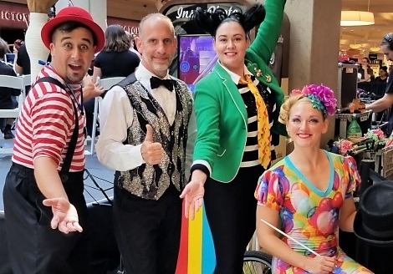
National Circus Project performers. Photo: Courtesy of the artists

WATER MILL, NY 1/31/2019—The Parrish Art Museum is presenting an interactive performance by the National Circus Project as part of Family Month, on Friday, February 15 at 6pm, free for Children, and included in admission for adults. The group will delight audiences of all ages with circus arts from around the world—juggling, unicycling, balancing, and object manipulations. Audience participation is encouraged. The performance is free for students and children; and for adults with Museum admission. Reservations are recommended. The Golden Pear Café will be open during the performance.
“We are delighted to welcome the National Circus Project to kick off Family Month at the Museum,” said Jillian Bock, Museum Education Associate. “Their interactive performance allows audience members to become active participants in the show—and learn some circus skills on their own! Our upcoming workshops provide many opportunities for families to work collaboratively through movement, art-making, and even coding.”
The National Circus Project packs a panoramic presentation of circus skills into its sensational comedy-variety shows. At the Friday program, two members of the group will perform, followed by a mini workshop where participants may try their hand at circus skills including juggling, western rope spinning, and feather balancing. The seasoned, professionally trained performers/teachers make learning circus skills easy and exciting for people of all ages.
About the National Circus Project (NCP)
During the past 30+ years, NCP specialists have presented more than 12,000 circus performances and conducted more than 60,000 workshops involving more than six million participants. NCP founder Jean Paul Jenack established in-school circus programs in 1974. Ten years later, he and founder Meryl Schaffer incorporated Circus Education Specialists, Inc. (CES), which became the National Circus Project in 1988. In 1990, NCP Directors began an artist exchange program with international artists of merit who are placed in the organization’s American school residence programs. That same year, NCP arranged for the first American artists in history to perform at the Latvian State Circus, receiving a commendation from U.S. Congress for “helping to further the cause of international understanding.” NCP has been profiled on The Today Show, as well as in Disney Adventures Magazine, Parenting Magazine, My Weekly Reader, USA Today, Newsday, The New York Times, and more than 1,000 other newspapers and online journals.

FAMILY MONTH PROGRAMS
Free for children; Free for adults with Museum admission
Friday, February 15, 6 pm
Circus Performance with the National Circus Project

Saturday, February 23, 2 pm
Film & Live Performance: 4 Little Girls: Moving Portraits of the American Civil Rights Movement

Friday, March 1, 6pm
LEGO Night: 6–7pm Robotic Bee (For Children 5-7)
7:15–8:15pm Grumpy Bird Launcher (For 8 and older)

Saturdays, February 9, 16 and 23; March 9, 11 am–12:30 pm
Open Studio for Families

Sunday March 3, 2 pm
Bilingual Family Gallery Talk and Art Workshop

February 18-22
Winter Vacation Art Workshops
($40 | $30 for Members per session. Advance registration and payment required)

Sunday, March 10, 10 am–5 pm
COMMUNITY DAY: Ongoing activities 12-3pm

Friday nights are made possible, in part, by the generous support of The Corcoran Group, and Sandy and Stephen Perlbinder.

About the Parrish Art Museum
Inspired by the natural setting and artistic life of Long Island’s East End, the Parrish Art Museum illuminates the creative process and how art and artists transform our experiences and understanding of the world and how we live in it. The Museum fosters connections among individuals, art, and artists through care and interpretation of the collection, presentation of exhibitions, publications, educational initiatives, programs, and artists-in-residence. The Parrish is a center for cultural engagement, an inspiration and destination for the region, the nation, and the world.

