PARRISH ART MUSEUM
279 MONTAUK HIGHWAY, WATER MILL, NY 11976
T 631 283 2118 PARRISHART.ORG

FOR IMMEDIATE RELEASE
CONTACT: Susan Galardi 631-283-2118 x122 galardis@parrishart.org

ROBOTIC BEE & GRUMBY BIRD LAUNCHER LEGO WORKSHOP
THE PARRISH ART MUSEUM
FRIDAY, MARCH 1, 6PM FREE FOR CHILDREN

5-7 year olds build mobile bees and those 8 and older create the bird launchers while learning about robotics, programming, gears, and teamwork

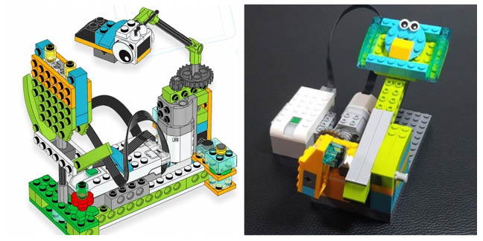

Robotic Bee and Grumpy Bird Launcher.

WATER MILL, NY 2/14/2019—As part of its Family Month celebrations, the Parrish Art Museum is hosting a LEGO® night for families to build robotic bees and grumpy bird launchers on Friday, March 1. Children 5-7 years old work on bees from 6-7pm; children 8 and older create bird launchers from 7:15 – 8:15. All LEGO® robots are disassembled at the end of the programs. The workshop is free for students and children; and is included with Museum admission for adults. Advance registration is required. The Museum galleries, featuring the 2019 Student Exhibition, and the Golden Pear Café will be open during the program.
,” said Jillian Bock, Museum Education Associate. “.”
Who is leading it? Last year: . Stephen W. Schwartz AIA, Architect of SWS Architects Livingston, New Jersey, and of Building Blocks Workshops, brings 70,000 LEGO® building blocks to the Parrish in this creative hands-on event
Both projects use LEGO® bricks and other materials – all supplied by the Museum. Children 5–7 years old will work in pairs with laptops to learn about gears, motors, sensors and programming to build a robotic bee that moves and stops to smell the flowers. Children in the older age group work in pairs on their robotic Grumpy Bird Launcher, learning techniques and applications of robotics, levers, gears, sensors, programming, and teamwork.
All children must be accompanied by adults. Registration online or by calling 631-283-2118 x130.
Families attending the program are invited to tour the Parrish galleries, where the 2019 Student Exhibition is currently on view, featuring work of more than 1,000 young artists from Eastern Long Island schools. A nearly 65-year tradition celebration of youthful imagination and boundless creativity, the Student Exhibition includes nearly 300 group and individual works created by students under the direction of their art teachers in 37 public, private, and home schools. This year, the exhibition was enhanced by Artist-in-Residence workshops with Shinnecock Nation member Jeremy Dennis, whose work is currently on view in the exhibition Every Picture Tells a Story.

FAMILY MONTH PROGRAMS
Free for children; Free for adults with Museum admission
Friday, February 15, 6 pm
Circus Performance with the National Circus Project

Saturday, February 23, 2 pm
Film & Live Performance: 4 Little Girls: Moving Portraits of the American Civil Rights Movement

Friday, March 1, 6pm
LEGO Night: 6–7pm Robotic Bee (For Children 5-7)
7:15–8:15pm Grumpy Bird Launcher (For 8 and older)

Saturdays, February 9, 16 and 23; March 9, 11 am–12:30 pm
Open Studio for Families

Sunday March 3, 2 pm
Bilingual Family Gallery Talk and Art Workshop

February 18-22
Winter Vacation Art Workshops
($40 | $30 for Members per session. Advance registration and payment required)

Sunday, March 10, 10 am–5 pm
COMMUNITY DAY: Ongoing activities 12-3pm

The Parrish Art Museum’s educational programming is supported, in part, by the Institute of Museum and Library Services; May and Samuel Rudin Family Foundation; The John J. McDonnell Margaret T. O'Brien Foundation; Bobbie Braun/The Neuwirth Foundation; The New York State Council on the Arts with the support of Governor Andrew M. Cuomo and the New York State Legislature; Patricia and David Rung; William Talbott Hillman Foundation; and Town of Southampton. Additional support for the Parrish education programs is provided by the Museum's annual Spring Fling and Midsummer Party benefit events.
The Museum's exhibitions and programs are made possible, in part, by the New York State Council on the Arts with the support of Governor Andrew M. Cuomo and the New York State Legislature, and the property taxpayers from the Southampton Union Free School District and the Tuckahoe Common School District.

Friday Nights are made possible, in part, by Presenting Sponsor, Bank of America. Additional support provided by The Corcoran Group, and Sandy and Stephen Perlbinder.

About the Parrish Art Museum
Inspired by the natural setting and artistic life of Long Island’s East End, the Parrish Art Museum illuminates the creative process and how art and artists transform our experiences and understanding of the world and how we live in it. The Museum fosters connections among individuals, art, and artists through care and interpretation of the collection, presentation of exhibitions, publications, educational initiatives, programs, and artists-in-residence. The Parrish is a center for cultural engagement, an inspiration and destination for the region, the nation, and the world.

