FOR IMMEDIATE RELEASE
PRESS CONTACT: Susan Galardi galardis@parrishart.org 631-283-2118 x122

PARRISH ART MUSEUM PRESENTS THOMAS JOSHUA COOPER: REFUGE –
THE ARTIST’S FIRST SOLO EXHIBITION IN AN AMERICAN MUSEUM IN TWO DECADES. MAY 5 – JULY 28, 2019

The exhibition features 49 photographs, anchored by 21 images Cooper
made on the East End of Long Island, exploring the notions of refuge and place

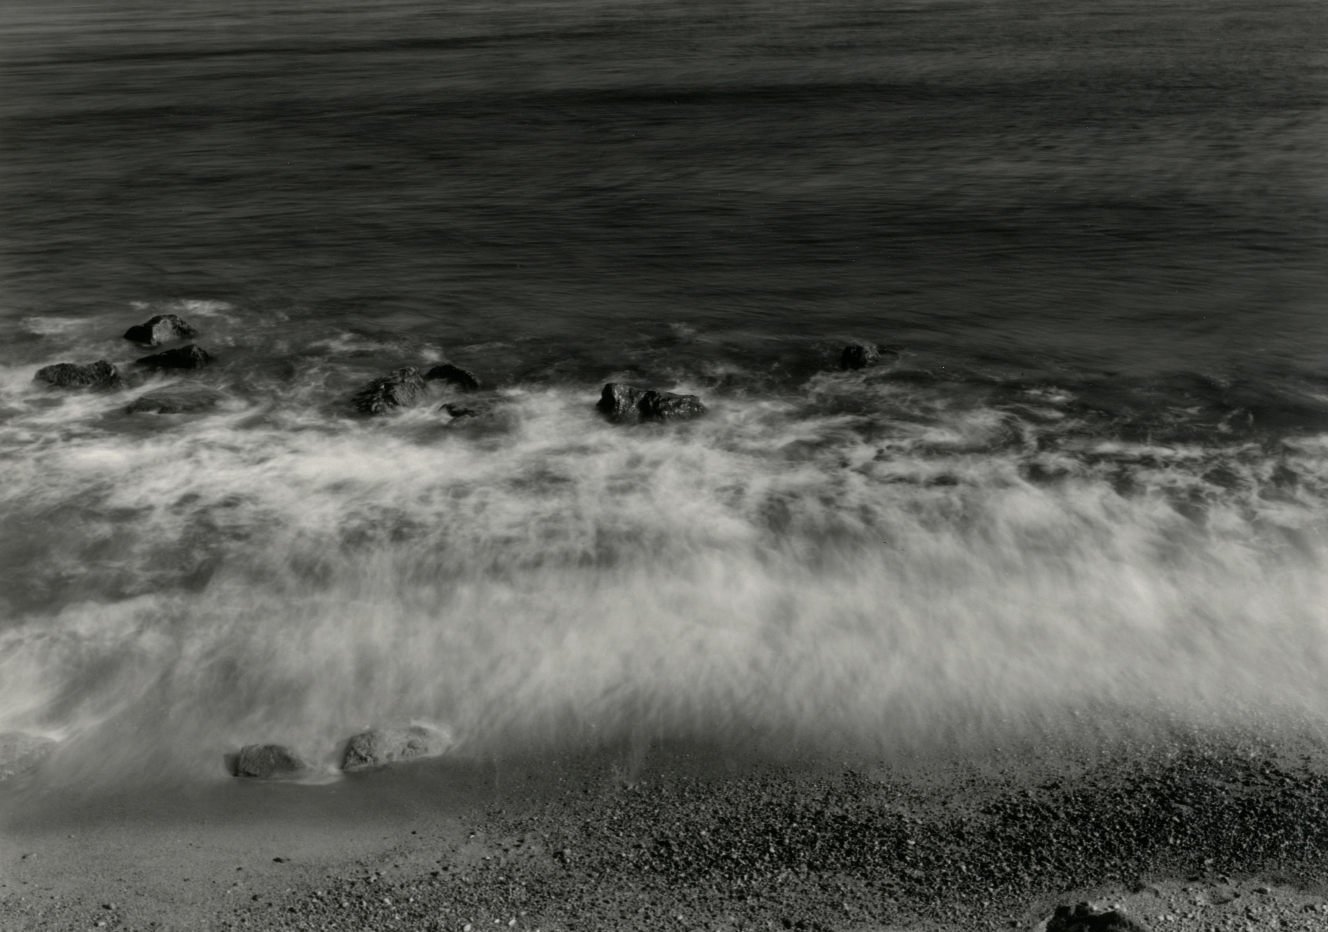
Thomas Joshua Cooper (American, born 1946) Incoming tide – looking east – North Atlantic Ocean, Montauk Point, New York, 2016/18. Selenium-toned gelatin silver print; 20 x 24 inches. Collection of the artist

WATER MILL, NY 4/12/2019—The Parrish Art Museum presents Thomas Joshua Cooper: Refuge, the artist’s first solo exhibition in an American museum in nearly two decades, on view May 5 through July 28, 2019. Throughout his 50-year career, Cooper has taken the role of as self-described “expeditionary artist” whose approach to photography borders between exploration and picture-making. Cooper’s images, made primarily along the coastal and inland waterways of the world, are steeped in the history of place, yet timeless in their aesthetic. Refuge features photographs made between 1998 to 2018 along the Eastern seaboard and the Hudson River, anchored by 21 images of seascapes and interior landscapes he made on the East End of Long Island during his 2016 exploratory commission sponsored by the Lannan Foundation with the Parrish Art Museum.

Inspired by the tradition of late 19th and early 20th century landscape photographers such as Timothy H. O’Sullivan (1840–1882), Carleton Watkins (1829–1916), and Edward Weston (1886–1958), Cooper’s images are scaled in the scope of a grand vista yet granular in detail. Made with a 19th-century large format camera, the 49 photographs in Thomas Joshua Cooper: Refuge, often intangible, embody an unusual depth and beauty.

“For Cooper, the relationship between history and ecology—from the Hudson River’s fresh water arterial to Long Island’s diverse waterways—holds great personal significance as a visual and emotional continuum of his sense of place in the world,” noted Parrish Director and exhibition curator Terrie Sultan. “These places, divergent in topography and habitat, share specific importance to both Native Americans and successive waves of immigrants. Each has been a significant socio-economic driver for trade, manufacture, and shipping, and has nurtured nascent artist communities in the 19th and 20th centuries.”

Each location Cooper identifies is recorded in a single negative taken with the 1898 AGFA field camera that he has used since 1968. His meticulously hand printed, selenium-toned gelatin silver prints are redolent with sumptuous detail and resonant tonalities, as depicted in the granular texture of pebbles and shells blending into the shallows in Gardiners Bay, Orient Point (2016/2017); and the intangible yet palpable movement of the wave and sea spray overtaking the shore in Incoming tide - Looking East, The North Atlantic Ocean, Montauk Point (2016/2018).

Cooper’s photographs, which he makes after a period of immersion in a specific site, are records of his deep personal connection to the land and its history. His process involves extensive research, exploration, and often arduous travel to raw, undomesticated environments on the periphery of civilization. The images are made in specific, real locations under particular light and weather conditions, yet they are void of identifying elements beyond the artist’s scrupulous naming conventions. Pictures such as Evening - Last light – “slight wind” A front garden (2016/2018) and Noontime – The Shinnecock Canal (2016/2017) epitomize Cooper’s ability to recover or infuse meaning into commonplace, forgotten, or seemingly anonymous locations.

While his methodology draws parallels to the photographer-as-explorer epitomized by O’Sullivan and Watkins, who captured iconic aspects of the American West, Cooper’s landscapes are largely abstracted, symbolic fields. Massachusetts Bay Looking towards the City of Boston (2009/2017) represents an intricate play light and pattern; Looking towards Manhattan and Long Island, Sandy Hook Bay and Lower New York Harbor (2009/2015) is a visual meditation of permanence and volatility, detail and haze.

Although Cooper has traveled worldwide making pictures along the Atlantic from the polar Arctic to South America, he had never been to eastern Long Island. Thus, in March 2016, the Parrish in collaboration with the Lannan Foundation invited the artist for a research trip. Over the course of 10 days, Cooper traversed the area, immersing himself in an internal dialogue about the region’s environment, history, and culture from Native Americans to Dutch and English settlers to the artist community that originated in the late 19th century and thrives today.

Images in Refuge record significant milestones within that timeline: Evening - Falling Light, Great Peconic Bay (2016/2018) captures an area on the reservation of the Shinnecock Indian Nation, a federally recognized tribe based in Southampton; Conscious Point, the locus of Midday Sun – Refuge, Conscious Point (2016/2016) is the site where the first English colonists landed in 1640; Midday – The Parrish Art Museum, Water Mill (2016/2016) was made on the grounds of the Museum that houses a collection representing generations of artists with significant ties to the region.

Thomas Joshua Cooper: Refuge is accompanied by a fully illustrated publication providing a fresh approach to experiencing and understanding the artist’s work. Terrie Sultan provides an overarching essay examining Cooper’s creative approach to image making, placing him within the context of history. David Kastan, George M. Bodman Professor of English at Yale University and noted Shakespearean scholar, contributes a philosophical musing on the nature of landscape photography. In a special section of book, former Parrish curatorial associate Michael Pinto shares his diary entries that document of his daily travels with Cooper.

About Thomas Joshua Cooper
Born in San Francisco in 1946, Thomas Joshua Cooper studied art, philosophy, and literature at Humboldt State University before completing his Master of Art in Photography at the University of New Mexico in 1972. His first solo show was held in 1971, and since then, he has been the subject of over 95 solo exhibitions throughout the world. Cooper’s work has also been included in over 80 group exhibitions. He has received numerous awards including a Photography Fellowship from the National Endowment for the Arts (1978) and, most recently, a John Simon Guggenheim Award (2009). In 2010, he became the first recipient of the Lannan Visual Arts Award.
Cooper’s photographs can be found in over 50 public collections worldwide, including The Art Institute of Chicago; The J. Paul Getty Museum; Los Angeles County Museum of Art; Museum of Contemporary Art, Chicago; Museum of Fine Arts, Houston; The Modern Art Museum, Fort Worth; Nimes Museum of Contemporary Art, France; The Polaroid Collection, Frankfurt; Princeton University Art Museum, New Jersey; The Tate Gallery, London; and The Victoria and Albert Museum, London. Lannan Foundation holds the single largest collection of work by the artist, who is the founding head of photography at the Glasgow School of Art.
Thomas Joshua Cooper: Refuge, is made possible, in part, by the generous leadership support of Century Arts Foundation, Lannan Foundation, The Liliane and Norman Peck Fund for Exhibitions, The Mr. and Mrs. Raymond J. Horowitz Fund for Publications, Linda Hackett and Melinda Hackett/ CAL Foundation, and Joyce Menschel.

About the Parrish Art Museum
Inspired by the natural setting and artistic life of Long Island’s East End, the Parrish Art Museum illuminates the creative process and how art and artists transform our experiences and understanding of the world and how we live in it. The Museum fosters connections among individuals, art, and artists through care and interpretation of the collection, presentation of exhibitions, publications, educational initiatives, programs, and artists-in-residence. The Parrish is a center for cultural engagement, an inspiration and destination for the region, the nation, and the world.

