PARRISH ART MUSEUM
279 MONTAUK HIGHWAY, WATER MILL, NY 11976
T 631 283 2118 PARRISHART.ORG

FOR IMMEDIATE RELEASE
CONTACT: Susan Galardi 631-283-2118 x122 galardis@parrishart.org

PARRISH ART MUSEUM ACQUIRES THREE LARGE-SCALE PAINTINGS BY DAVID SALLE— NEVER BEFORE SEEN IN THE U.S.— BASED ON MICHELANGELO’S SISTINE CHAPEL

The series “After Michelangelo” is featured in the Museum’s new permanent collection exhibition, on view November 11, 2018 – October 3, 2019

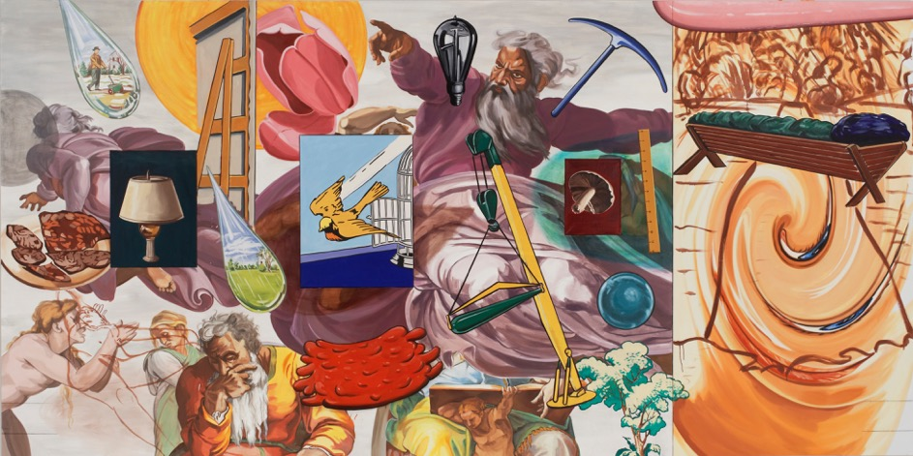
David Salle (American, b. 1952), After Michelangelo, The Creation, 2005–2006. Oil and acrylic on linen, 90 x 180 in.

WATER MILL, NY 11/8/18—The Parrish Art Museum has acquired three monumental works by David Salle based on the Sistine Chapel paintings by Michelangelo, titled After Michelangelo, The Creation; After Michelangelo, The Flood; and After Michelangelo, The Last Judgment. Never-before seen in the United States, the paintings will be unveiled as part of the Museum’s new permanent collection exhibition Every Picture Tells a Story, on view November 11, 2018 through October 3, 2019. The cycle was commissioned in 2004 for Museo Carlo Bilotti, Rome, and created by Salle between 2005 and 2006 in East Hampton, New York. Recognizing Salle’s decades-long ties to the East End of Long Island, Carlo Bilotti’s widow Margaret S. Bilotti gifted the works to the Parrish.

“We are extremely grateful to the Margaret Bilotti for this extraordinary gift,” said Terrie Sultan, Director of the Parrish Art Museum. “These monumentally-scaled paintings show Salle at his most inventive. The works add significantly to the Museum’s ability to show works by important American artists in depth, and to celebrate Salle’s connection to our community as well.”

A painter with a strong conceptual bent, David Salle (American, born 1952) incorporates disparate references from art history, film, literature, and religion into his work. In the After Michelangelo cycle, each work comprising two panels and measuring approximately 8 feet high and15 feet wide, Salle addresses a singular theme of the Sistine Chapel by juxtaposing references to Michelangelo’s signature paintings with a host of images culled from popular cultural, contemporary news events, and art history.

In The Flood (90 x 185 in.), Salle updated the biblical story of the deluge from the Book of Genesis with references to natural disasters such as the 2004 Asian tsunami and Hurricane Katrina. The Creation (90 x 180 in.), dominated by the god figure in The Creation of Adam, includes references to human ingenuity and new beginnings, with imagery of an industrial light bulb, tools, and machines. In The Last Judgement (96 x 183 in.) figures from Michelangelo’s fresco on the Sistine Chapel altar wall are overtaken by images of doom and destruction: missiles, Satan, and a scythe-wielding personification of death.

In this sixth iteration of special exhibitions drawn from the collection, Every Picture Tells a Story offers viewers many different avenues for experiencing contemporary approaches to narrative and figuration. In addition to Salle’s paintings, for example, the Parrish will also unveil a series of newly acquired Photorealist paintings including Bertrand Meniel’s depictions of everyday urban life in Breakfast at the Fairmont, 2009, and Tom Blackwell’s Morning Walk, Hampstead High Street, London, 2011. Other exhibitions within Every Picture Tells a Story include galleries dedicated to Fairfield Porter, William Merritt Chase (1849–1916), and Louisa Chase (1951-2016); and a series of black-and-white portraits of artists such as Willem de Kooning, Jackson Pollock, Charlotte Park, and Elaine de Kooning—all captured by the inquisitive lens of documentary photographer Fred McDarrah (1926–2007).

Every Picture Tells a Story, the 2018 Permanent Collection Exhibition, has been made possible, in part, by the generous support of Barbara Slifka, Ellen Cantrowitz, Garrett and Mary Moran, Charlotte Moss and Barry Friedberg, Jane and David Walentas, and Per Skarstedt.

About the Parrish Art Museum
Inspired by the natural setting and artistic life of Long Island’s East End, the Parrish Art Museum illuminates the creative process and how art and artists transform our experiences and understanding of the world and how we live in it. The Museum fosters connections among individuals, art, and artists through care and interpretation of the collection, presentation of exhibitions, publications, educational initiatives, programs, and artists-in--residence. The Parrish is a center for cultural engagement, an inspiration and destination for the region, the nation, and the world.

