PARRISH ART MUSEUM
279 MONTAUK HIGHWAY, WATER MILL, NY 11976
T 631 283 2118 PARRISHART.ORG

FOR IMMEDIATE RELEASE
CONTACT: Susan Galardi 631-283-2118 x122 galardis@parrishart.org

PARRISH ART MUSEUM PRESENTS
RENATE ALLER: THE SPACE BETWEEN MEMORY AND EXPECTATION,
AN IMMERSIVE INSTALLATION OF LARGE SCALE, MYSTICAL IMAGES
ON VIEW MARCH 24 TO JULY 28, 2019

Part of the Parrish Perspectives series, Aller’s photographs explore the relationship of romanticism, memory, and place
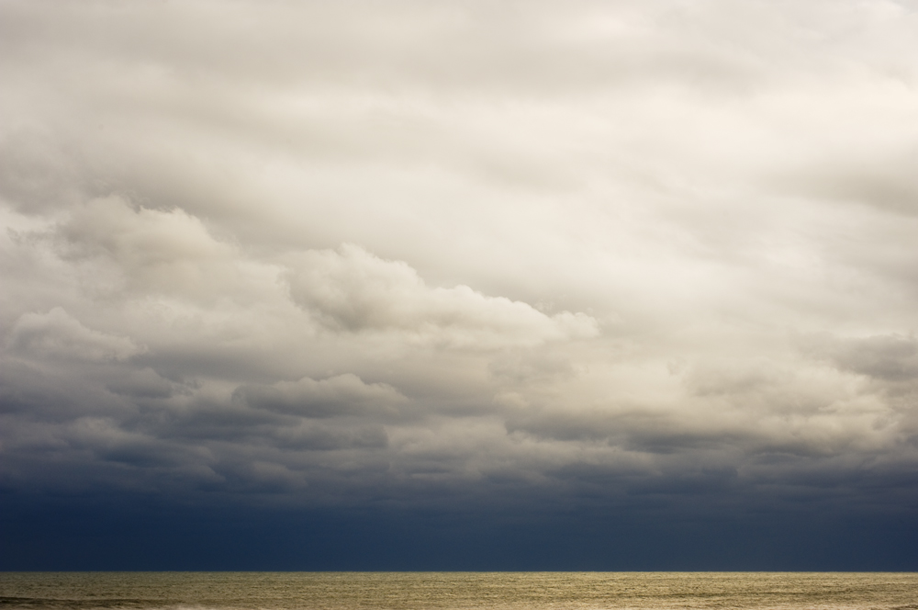.
Renate Aller (German, born 1960) Ocean | Desert, Atlantic Ocean, October 2009

WATER MILL, NY 3/7/19—The Parrish Art Museum presents Renate Aller: The Space Between Memory and Expectation, a focused exhibition of works by the German-born photographer illuminating her exploration of the interrelationship of romanticism, memory, and place through dynamic compositions rich with implied narratives. On view at the Museum from March 24 to July 28, 2019, the exhibition features 12 large-scale archival prints in a gallery installation specifically designed to present a compositionally unified environment. Presenting works drawn from ongoing series Ocean | Desert and Mountain Interval, the exhibition draws together disparate landscapes through the continuity of the horizon line. Dramatic images of the Atlantic Ocean, vast sand dunes in New Mexico and Colorado, and the majestic mountain ranges in Alaska, Switzerland, Italy, and Nepal come together to explore “the interval, the space in between … during which apparently nothing happens, but without which no change could happen,” Aller explains. “The Space Between Memory and Expectation is another way to describe this state of stillness and transition.”

The Space Between is part of Parrish Perspectives—a series of concentrated exhibitions that offers the Museum opportunities to respond spontaneously and directly to unique ways of thinking about art, artists, and the creative process. In the immersive installation, seven photographs of dramatic ranges and peaks from Mountain Interval are aligned with five prints from Ocean | Desert—broad expanses of sea and sand. The viewer is surrounded by a panorama that smoothly transitions from mountains to ocean as the eye is guided from image to image along a compositionally coherent horizon line.

“Having this opportunity to experience an expansive and broadly divergent sample of the natural world—the mountains, the desert, and the sea—in this uniquely unified installation is very exhilarating,” Parrish Director Terrie Sultan said. “Aller’s eye for the power and beauty of the landscape is transformative.”

Aller launched a systematic study of a singular view of the Atlantic Ocean in 1999 when she moved to the south shore of Long Island and began to photograph the seascape from the exact same vantage point at different times of day, year round. A low horizon line grounds the images, while the mutability of weather and sky obliterates any vestige of sameness. The stormy Ocean | Desert, Atlantic Ocean, October 2009, is an image of glory, despair, and hope where a strip of ocean glows gold beneath a band of black sky that gradually yields to progressively lighter clouds. Ocean | Desert #27, Atlantic Ocean, 2013, presents a seascape before or after a storm, where glimmers of light on the water hint at the presence of sun. Two images of the Colorado Great Sand Dunes elicit both a sense of security and a place on the brink of drama. In the lyrical, monochromatic Ocean | Desert #5, Colorado Great Sand Dunes, May 2013, human figures are humbled by the enormity of dunes that may embrace or engulf them.

In Mountain Interval, Aller departs from the horizontal planes of sea and dunes while maintaining a calm intensity. She approaches the subjects of rock and snow as if they are portraits not only of place and time, but emotional and psychological attachment. Standing at elevations as high as 22,500 feet, she captures mountain tops removed from contextual surroundings and human presence, resulting in a sense of permanence and authority as well as displacement and unease. In PLATE 53 #28s, Nepal, Himalayas, Everest Region, December 2016; and PLATE 21 #37s, Nepal, Himalayas, Langtang Region, December 2016, jagged formations impose themselves against a white sky in a depiction of stillness and transition, while appearing to move off the edges of the frame and the face of the earth. PLATE 41 #21s, Swiss Alps, April 2016 is a masterful landscape of lyrical mountain peaks nestled in milk white clouds that may be rising to celestial heights or concealing what lies beneath. In all their contradiction and beauty, Aller’s photographs convey a sense of the transcendent grandeur inherent in the natural world.

Renate Aller: The Space Between Memory and Expectation is made possible, in part, by the support of Belinda Buck Kielladnd, Krista and Michael Dumas, Janice Sarah Hope, Adam Miller Group, Marc Olivié and Marleen De Bode Olivié, and Michèle and Steven Pesner.

RELATED PROGRAM
Friday, May 24, 6pm
TALK & BOOK SIGNING: Renate Aller, Mountain Interval
The artist discusses her most recent book project with Parrish Art Museum Director Terrie Sultan

About the Parrish Art Museum
Inspired by the natural setting and artistic life of Long Island’s East End, the Parrish Art Museum illuminates the creative process and how art and artists transform our experiences and understanding of the world and how we live in it. The Museum fosters connections among individuals, art, and artists through care and interpretation of the collection, presentation of exhibitions, publications, educational initiatives, programs, and artists-in-residence. The Parrish is a center for cultural engagement, an inspiration and destination for the region, the nation, and the world.

# # #

