PARRISH ART MUSEUM
279 MONTAUK HIGHWAY, WATER MILL, NY 11976
T 631 283 2118 PARRISHART.ORG

FOR IMMEDIATE RELEASE
CONTACT: Susan Galardi, Communications Director
631-283-2118 x122 galardis@parrishart.org

PARRISH ART MUSEUM PRESENTS
JEAN-LUC MYLAYNE: A MATTER OF PLACE, REVEALING THE ARTIST’S HIGHLY PERSONAL VIEW OF LANDSCAPE AND NATURE. MARCH 24 – JULY 20, 2019

Part of the Parrish Perspectives series, the exhibition features monumentally scaled photographs drawn from the permanent collection that illuminate the intimate bond between subject and photographer

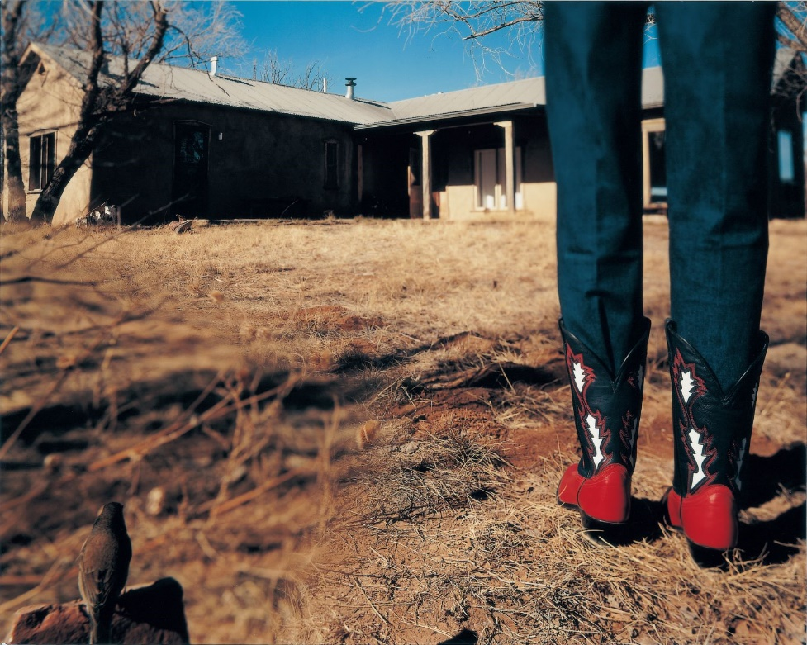
Jean-Luc Mylayne (French, born 1946) No. 186, January February 2004, 2004; C-print, 48 x 60 inches.
Parrish Art Museum, Water Mill, N.Y., Gift of Mylene and Jean-Luc Mylayne.

WATER MILL, NY 3/7/19—The Parrish Art Museum presents Jean-Luc Mylayne: A Matter of Place, monumentally scaled photographs by the French artist who juxtaposes natural and man-made, stillness and motion, calm and tension within poetic and mysterious photographs. On view from March 24 to July 28, 2019, the exhibition reflects the artist’s almost metaphysical approach to image-making. Through his lifetime pursuit to photograph commonplace birds in natural habitats, Mylayne has engaged in a profound investigation of how humankind and nature can coexist. The exhibition features nine images made in New Mexico and Texas, gifted to the Parrish by the artist and the Lannan Foundation. A Matter of Place is part of Parrish Perspectives—a series of concentrated exhibitions that offers the Museum opportunities to respond spontaneously and directly to unique ways of thinking about art, artists, and the creative process.

Parrish Director Terrie Sultan met Mylayne in 2006 in Alpine, Texas, where he and his wife and collaborator Mylène spent several years photographing bluebirds—a species of special significance to Mylayne as their color is symbolizes nature for the artist. The exhibition Sultan organized traveled throughout the United States, completing the tour at the Parrish Art Museum in 2009.

“Although these images were made in the American West, they resonate strongly with the natural habitat of Long Island’s East End. Mylayne’s compositions and his approach to art-making echo that of the late nineteenth- century plein air paintings for which this region is renowned.” Sultan explains. “His story is universal—about the interactions between humans and the natural world. To have these stirring photographs in the Parrish collection allows for a thoughtful and innovative conversation and beautiful visual experience.”

Although Mylayne’s pursuit for more than 30 years has been to photograph birds, he is not a documentarian or a naturalist. The artist explores the intimate bond between subject and photographer through exacting conception, visionary inventiveness, and infinite patience. His process, which may take weeks, months, or years to realize, involves scouting a site, locating birds in the field, and acclimating himself and his skittish subjects to one another before determining the precise moment to take the photograph. Unlike a traditional nature photographer, Mylayne’s goal isn’t to capture the likeness of the bird but to understand how human beings fit in the world of nature, even though people are rarely portrayed in his work. Human-avian contact is most direct in No. 186 January February 2004, where a dark-eyed junco confidently shares space with an individual represented only by denim-clad legs and red, white, and black cowboy boots. The junco is surely aware of the person, who is most likely oblivious to the bird positioned slightly behind her, camouflaged on its rock perch.

This image also illuminates the multiple points of focus Mylane achieves in a single photograph by layering his personally designed lenses, in effect reconfiguring the landscape to replicate what is seen by the naked eye. Like a filmmaker, the artist directs the viewer around the frame through his use of soft and sharp focus. In No. 258, January February 2004, 2004, the eye is drawn to the sharply defined sunlit bluebird against a blurred patch of ground and off-focus objects on either side. An imposing building with dramatic angles and shapes confirms human presence. Yet the bird boldly claims its place in civilization, perched between a hatchet and stick of firewood to be cut, literally in the middle of the quotidian work of the home’s inhabitants.

No. 300, March April 2005, 2005 captures a brilliant vermillion bird poised on the tip of a branch. No signs of humans are visible, yet the bird’s defiant stare and its body, lurching in anticipation of flight or fight, is evidence of the photographer’s presence. These and other images in Jean-Luc Mylayne: A Matter of Place reveal the artist’s keen aptitude for observation, technical invention, and moral imperative for ecological harmony.

Jean-Luc Mylayne, born in Amiens, France in 1946, has had major solo exhibitions at Barbara Gladstone Gallery, New York, Musée d’Art Moderne de la Ville de Paris and the Musée d’Art Moderne, Saint-Etienne; the Photographers’ Gallery, London; the ARC/Muse d’Art Moderne de la Ville de Paris; and the Boca Raton Museum of Art, Boca Raton, Florida. In 20009, the Parrish Art Museum presented the artist’s first solo American museum exhibition, curated by Terrie Sultan and comprising 22 large-scale color photographs of birds taken in West Texas from 2004 to 2007. Though he began working in 1976, Mylayne has created no more than 150 unique photographs.

About the Parrish Art Museum
Inspired by the natural setting and artistic life of Long Island’s East End, the Parrish Art Museum illuminates the creative process and how art and artists transform our experiences and understanding of the world and how we live in it. The Museum fosters connections among individuals, art, and artists through care and interpretation of the collection, presentation of exhibitions, publications, educational initiatives, programs, and artists-in-residence. The Parrish is a center for cultural engagement, an inspiration and destination for the region, the nation, and the world.

