PARRISH ART MUSEUM
279 MONTAUK HIGHWAY, WATER MILL, NY 11976
T 631 283 2118 PARRISHART.ORG

FOR IMMEDIATE RELEASE
CONTACT: Susan Galardi 631-283-2118 x122 galardis@parrishart.org

PARRISH ART MUSEUM CELEBRATES THE CREATIVITY OF 1,000 YOUNG ARTISTS AT THE 2019 STUDENT EXHIBITION, FEBRUARY 9 – MARCH 10, 2019

This year’s annual exhibition features art by students from 37 schools and work created by 350 students with Artist-in-Residence Jeremy Dennis
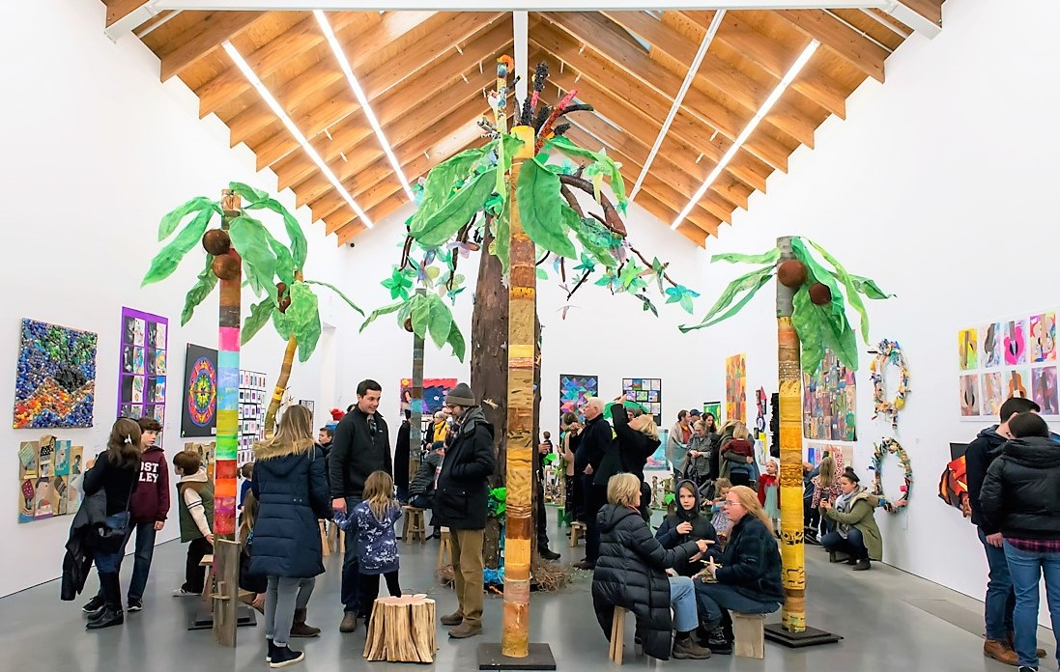
Opening of the 2018 Student Exhibition at the Parrish Art Museum. Photo: Daniel Gonzalez

WATER MILL, NY 1/25/2019—From February 9 through March 10, the work of more than 1,000 young artists from Eastern Long Island schools will on view in the Parrish Art Museum’s annual Student Exhibition. A nearly 65-year tradition celebration of youthful imagination and boundless creativity, this important aspect of the Museum’s programs was enhanced this year by Artist-in-Residence workshops with Shinnecock Nation member Jeremy Dennis, whose work is currently on view in the exhibition Every Picture Tells a Story and who will attend the opening receptions for the exhibition on Saturday, February 9. The exhibition opening kicks off Family Month at the Museum, featuring a live circus performance with the National Circus Project on February 15; a film & live performance event (4 Little Girls: Moving Portraits of the American Civil Rights Movement) on February 23; LEGO Night workshops on March 1; and a free Community Day on March 10.

“The Parrish looks forward to the enthusiasm for art making and the creativity expressed in the Student Exhibition every year. That energy is amplified this year by the Museum’s fifth Artist-in-Residence in the new facility, with the participation of collection artist Jeremy Dennis,” said Parrish Director Terrie Sultan. “This continues to allow the Parrish to provide the inspiring opportunity for hundreds of students to work with practicing contemporary artists.”

Participants in the Student Exhibition explore many traditional and non-traditional approaches to art-making. Working with their art teachers and through art clubs in schools from Bellport to East Hampton and the North Fork, the students demonstrate imagination, enthusiasm, and technical skill in diverse media such as painting, sculpture, drawing, photography, and costume design. Taken together, the exhibition gives an overview of the high level of creativity and accomplishment achieved in the schools.

“Each year, the Student Exhibition showcases the work of our community’s young artists and art educators,” said Parrish Education Director Cara Conklin-Wingfield. “The visual arts are a means of personal expression and communication for all ages—we hope the exhibition inspires all our visitors to make art and helps our student artists form a lifelong appreciation for art.”

Elementary and middle schools enter group projects; high school artists are represented by individual works and collaborative projects. Artist Neill Slaughter, a professor of Visual Art at Long Island University, will present awards to recognize select high school seniors for their exceptional talent and skill, in categories ranging from painting to mixed media. “Ones to Watch” honors are given to underclassmen.

In addition to the nearly 300 group and individual works created by students under the direction of their art teachers in 37 public, private, and home schools, the exhibition features group works by over 350 students from Southampton and Hampton Bays Life Skills, and Bridgehampton, East Hampton, Hayground, Southampton, and Tuckahoe Schools who participated in the residency and created work inspired by Jeremy Dennis’s conceptual and technical approach to storytelling though his photography. At each session, the artist discussed his work based on his re-interpretation of Native American mythology and actual events, read a Native American myth, and prompted the students to create art inspired by the concept of personal transformation.

Participating schools in the 2019 Student Exhibition include:
High Schools: Bellport, Bridgehampton, East Hampton, Eastport South Manor, Eastern Long Island Academy of Applied Technology, Greenport, Hampton Bays, Mattituck, Miller Place, Pierson, Riverhead, Ross, Southampton, Westhampton Beach, William Floyd School District.

Elementary, Middle, and Home Schools: Bridgehampton, Children’s School, Cutchogue East Elementary, East Hampton Middle, East Quogue, Hayground, Hampton Bays Middle, On the Bay Homeschool Group, North Fork, John M. Marshall Elementary, New Suffolk Common School, Our Lady of the Hamptons, Oysterponds Elementary, Peconic Community, Raynor Country Day, Ross Lower and Upper Schools, Sag Harbor Elementary, SCNY Homeschool Group, Shelter Island Early Learning Center, Southampton Elementary, Southampton Intermediate, Southampton Montessori

PARRISH ART MUSEUM 2019 STUDENT EXHIBITION
Saturday, February 9 – Sunday, March 10, 2019
Admission--exhibition and opening receptions--free for participating educators, artists, and their families.

STUDENT EXHIBITION RECEPTIONS: Free events with refreshments
Saturday, February 9, 1–3 pm: Young Artists Reception
Saturday, February 9, 3–5 pm: High School Artists Reception
Saturday, March 3, 3 pm: High School Awards Presentation and Reception

FAMILY MONTH PROGRAMS: Free for children; Free for adults with Museum admission
Friday, February 15, 6 pm: Circus Performance with the National Circus Project
Saturday, February 23, 2 pm: Film & Live Performance: 4 Little Girls: Moving Portraits of the American Civil Rights Movement
Friday, March 1, 6 – 7pm: LEGO Night I: Robotic Bee (For Children 5-7 years old)
Friday, March 1, 7:15–8:15pm: LEGO Night II: Grumpy Bird Launcher (For Children 8 and older)

OPEN STUDIOS & WORKSHOPS
Saturdays, February 9, 16, and 23; March 9, 11 am–12:30 pm: Open Studio for Families
Sunday March 3, 2 pm: Bilingual Family Gallery Talk and Art Workshop
February 18-22: Winter Vacation Art Workshops:
($40 | $30 for Members per session. Advance registration and payment required)

COMMUNITY DAY:
Sunday, March 10, 10 am–5 pm. Ongoing activities 12-3pm.

The 2019 Student Exhibition and accompanying programs are supported in part by property taxpayers from the Southampton School District and Tuckahoe Common School District.
The Parrish Art Museum’s educational programming is supported, in part, by Bobbie Braun/The Neuwirth Foundation; the Institute of Museum and Library Services; May and Samuel Rudin Family Foundation; The John J. McDonnell Margaret T. O’Brien Foundation; The New York State Council on the Arts with the support of Governor Andrew M. Cuomo and the New York State Legislature; Patricia and David Rung; William Talbott Hillman Foundation; and Town of Southampton. Special thanks to the Art Spirit Foundation. Additional support for the Parrish education programs is provided by the Museum’s annual Spring Fling and Midsummer Party benefit events.

About the Parrish Art Museum
Inspired by the natural setting and artistic life of Long Island’s East End, the Parrish Art Museum illuminates the creative process and how art and artists transform our experiences and understanding of the world and how we live in it. The Museum fosters connections among individuals, art, and artists through care and interpretation of the collection, presentation of exhibitions, publications, educational initiatives, programs, and artists-in residence. The Parrish is a center for cultural engagement, an inspiration and destination for the region, the nation, and the world.

