PARRISH ART MUSEUM
279 MONTAUK HIGHWAY, WATER MILL, NY 11976
T 631 283 2118 PARRISHART.ORG

FOR IMMEDIATE RELEASE
CONTACT: Susan Galardi 631-283-2118 x122 galardis@parrishart.org

PARRISH ART MUSEUM HOSTS “TWO FORKS AND A CORK” – A CELEBRATION OF EAST END WINE & SPIRITS, FOOD PURVEYORS, MUSIC, AND COMMUNITY, SATURDAY, MARCH 9, 6 – 8 PM

Organized by the Parrish Business Council, the public event offers casual networking, live music, and tastings from Channing Daughters, Kontakosta, Macari, Paumanok, and Sagaponack Farm Distillery

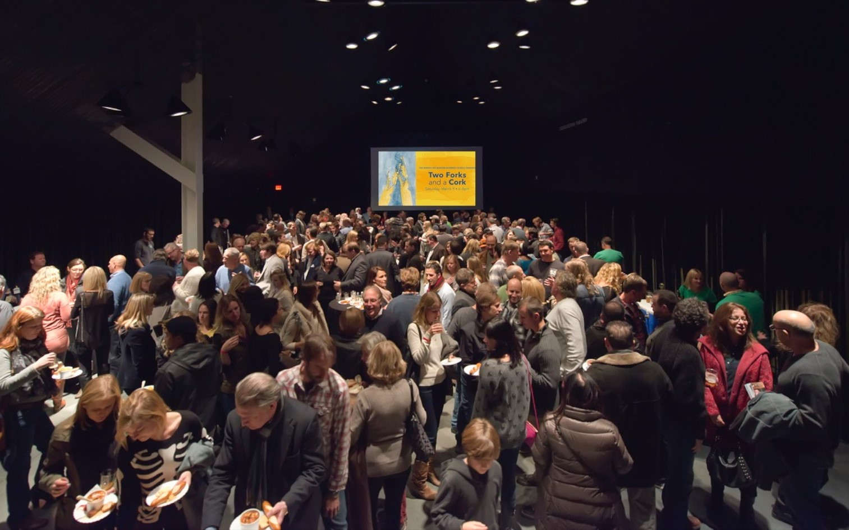

WATER MILL, NY 3/1/2019—On Friday, March 9 from 6–8 pm, the Parrish Art Museum Business Council is hosting Two Forks and a Cork—an evening of local wine and spirits tastings, hors d’oeuvres, live music, and gallery exploration in an ideal setting for socializing and networking. The event features a selection of white, rosé, and red wines from premiere East End vineyards and vodka mixed drinks from a local craft distillery. Admission for Two Forks and a Cork, open to attendees 21 and older, is $55 for Parrish Members, $75 for Nonmembers.

“The Museum is grateful to the Business Council for their enthusiasm and diligence in organizing this event that engages the community, and to our sponsors for their generous support” said Chris Siefert, Parrish Art Museum Deputy Director.

Guitarist Mike Gari and bass player Steve Shaughnessy will perform live throughout the event, as guests sample a variety of select wines from Channing Daughters Winery, Kontokosta Winery, Macari Vineyards, and Paumanok Vineyards, plus cocktails crafted with vodka produced by Sagaponack Farm Distillery. All wine and spirit producers will be on hand to discuss their processes and products. Special hors d’oeuvres and snacks are provided by The Golden Pear, Cavaniola's Gourmet Cheese Shop in Sag Harbor, and The Seafood Shop in Wainscott – as well as additional libations courtesy of Vinizzo.

At their leisure throughout the evening, guests may visit the galleries to see Every Picture Tells a Story. The new installation of nearly 100 works from the Museum’s more than 3,000 piece collection explores the how images carry narrative meaning and presents 40 important new acquisitions including three monumental paintings by David Salle inspired by the Sistine Chapel. Photorealism provides a provocative context to the conversation about representation and imagery through paintings by artists such as Tom Blackwell, Bertrand Meniel, Yigal Ozeri, and Charles Bell. Into the Artist’s World presents 27 photographs by Fred McDarrah, who chronicled New York post-war culture for The Village Voice. Fairfield Porter Raw: The Creative Process of an American Master reveals Porter’s creative process and working method through finished and unfinished paintings of his family, friends, studio, and homes. Louisa Chase: Below the Surface features 18 works by the artist who provided a view into her inner life through abstraction. A Fresh Look presents largely abstract paintings and sculpture that explore the nuance between dark and light through works by Alice Aycock, Louise Nevelson, Donald Sultan, and others. In William Merritt Chase: The Shinnecock Years, paintings by the artist and his students are augmented by archival photographs that reveal the close relationship between the artists and the Shinnecock Indian Nation. Four contemporary artists explore concepts of self-definition in Shaping Identity.

Also on view is the 2019 Student Exhibition, and celebration of youthful creativity featuring work by more than 1,000 young artists from 37 Eastern Long Island schools from Pre-K to High School, plus work created in a residency with Shinnecock Indian Nation member Jeremy Dennis, who conducted workshops for 350 students based on his approach to storytelling combining photography, Native American mythology, and actual events.

About the Parrish Business Council
The Parrish Business Council is a volunteer committee of East End professionals serving culturally engaged business leaders and organizations by providing programs and networking opportunities for Parrish Business Members and their guests. Current Council Members are Eugenia Au Kim, Liz Brodar, Keith Davis, Emil K. Everett, Erik Fredrickson, Nadine Homann, Aleksandra Kardwell, Robin L. Long, Esq (Chair), Jan Rose, Lisa Saladino, and Diana Pepi Stott. The Council provides opportunities for social and professional networking such as Two Forks and a Cork and produces events for Business Members that contribute to professional development. Held at the Museum, the programs allow guests to explore the galleries with fellow Business Members and invited guests. Recent events include The Art of Conversation—a micro-focused workshop led by Emil Everett on how to connect more meaningfully with other in a short period of time. Eugenia Au Kim led The Art of Living Spaces: Feng Shui for Businesses— an interactive conversation and workshop on the challenges and cures for workplaces and businesses ranging from restaurants and hospitality to retail, banks, and home offices. On May 2, Erik Fredrickson will lead Spring Awakening: Inspirational Goalsetting for Businesses.

The Parrish Art Museum is grateful to its corporate sponsors for their support (list in formation). Cabernet Sauvignon Level: BNB Bank and Bridge Abstract, Cavaniola's Gourmet Cheese Shop, Long and Mattone, LLP, Men at Work Construction, The Golden Pear Café, Topping Rose House, White Fences Inn. Chardonnay Level: Halcyon Design, LLC, The Baker House 1650. Rosé Level: 3 Moms Organics, Christine Curiale, VP, Valley National Bank, Dazel Electrical, Dios Katz Group, UBS, Fidelity National Title Insurance Co., Hampton Gymnastics East, Kathryn Markel Fine Arts, Kevin White Associates - Executive Coaching, Millstone Flower Studio, Scott Sanders LLC, Shine, Stony Hill Stables, The Seafood Shop, Titlevest, a First American Company.
About the Parrish Art Museum
Inspired by the natural setting an artistic life of Long Island’s East End, the Parrish Art Museum illuminates the creative process and how art and artists transform our experiences and understanding of the world and how we live in it. The Museum fosters connections among individuals, art, and artists through care and interpretation of the collection, presentation of exhibitions, publications, educational initiatives, programs, and artists-in-residence. The Parrish is a center for cultural engagement, an inspiration and destination for the region, the nation, and the world.

