PARRISH ART MUSEUM
279 MONTAUK HIGHWAY, WATER MILL, NY 11976
T 631 283 2118 PARRISHART.ORG

FOR IMMEDIATE RELEASE
CONTACT: Susan Galardi 631-283-2118 x122 galardis@parrishart.org

AT COMMUNITY DAY, THE PARRISH ART MUSEUM CELEBRATES FAMILIES AND FRIENDS WITH FREE ADMISSION TO THE MUSEUM AND ACTIVITIES
SUNDAY, MARCH 10
Art and music making workshops and gallery tours are scheduled from noon to 3 pm, along with refreshments and treats

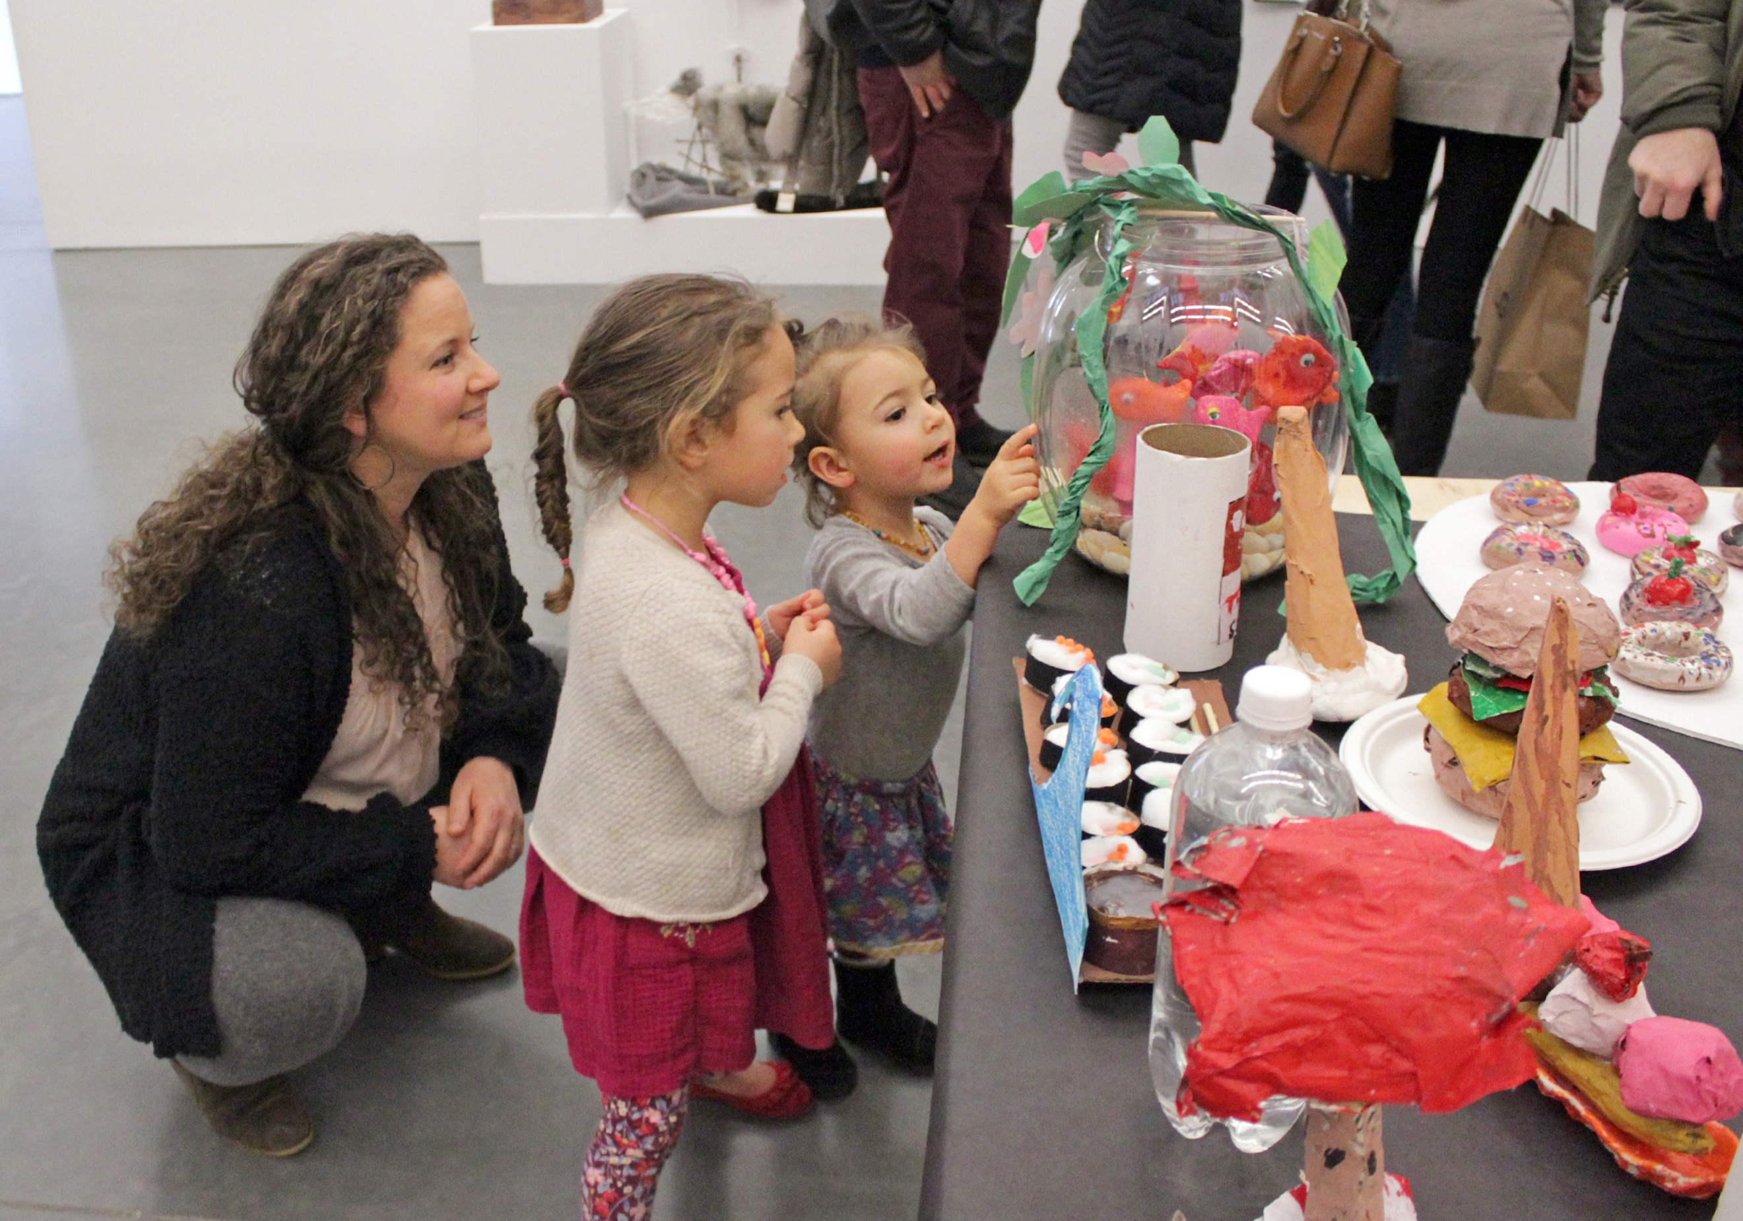
Opening of the 2019 Student Exhibition at the Parrish Art Museum. Photo: Tom Kochie

WATER MILL, NY 2/28/2019—The Parrish Art Museum continues its month-long celebration of the community, families, and young artists with a free Community Day on Sunday, March 10. This festive event is the culmination of the Museum’s Family Month, welcoming the entire community with a day of art workshops led by artists and Museum educators, zip-tours of exhibitions, art scavenger hunts, children’s book reading, drumming circle, complementary refreshments, and free admission to the Museum for all. The Museum is open and free to the public 10 am to 5 pm; activities are scheduled between noon and 3 pm.

“Community Day is an opportunity for members of the public—adults, children, and families—to experience all that the Parrish Art Museum has to offer year round: engaging art exhibitions; creative and fun art workshops for children and adults. What is most important is the opportunity for all to engage with art, artists, and one another,” said Parrish Director Terrie Sultan. “We invite the entire community to join us and we especially look forward to welcoming anyone who has not yet visited the Parrish. The Museum is here for everyone.”

Community Day activities—scheduled throughout the Museum between noon and 3 pm—include a wide array of art and music making opportunities. At 12:30 pm in the galleries, guests can join a special interactive drumming workshop facilitated by musician Jerome Liggon. At 1:30 in the lobby, illustrator Ellen Weinstein will give a reading of her charming, whimsical children’s book Yayoi Kusama: From Here to Infinity.
Ongoing art workshops inspired by the Student Art Exhibition take place in the lobby and studio. Museum educator Madolin Archer will teach children and families how to create a special type of ink prints. Parrish collection artist Virva Hennemo will lead workshops on constructing a unique form of paper sculpture; and illustrator Weinstein will engage participants in developing their own collages inspired by the work of the brilliant Japanese artist Yayoi Kusama. At their own pace, families can have fun exploring the Parrish collection through an engaging art scavenger hunt.
Between noon and 3 pm, Parrish Art Museum docents will be on hand to lead mini “zip-tours” of the two exhibitions on view: the 2019 Student Art Exhibition and the Permanent Collection exhibition, Every Picture Tells a Story. The Student Exhibition features work by more than 1,000 young artists from 37 Eastern Long Island schools from Pre-K to High School, plus work created in a residency with Shinnecock Indian Nation member Jeremy Dennis, who conducted workshops for 350 students based on his approach to storytelling combining photography, Native American mythology, and actual events Every Picture Tells a Story is an eight-gallery installation that explores how images carry narrative meaning. More than 100 works on view—featuring 40 important new acquisitions that include artist portraits by the iconic photographer Fred W. McDarrah, and paintings by David Salle and Photorealist artists—invite viewers to create their own interpretations.
COMMUNITY DAY:
Sunday, March 10, 10 am–5 pm. Ongoing activities 12-3pm.

The 2019 Student Exhibition and accompanying programs are supported in part by property taxpayers from the Southampton School District and Tuckahoe Common School District. The Parrish Art Museum’s educational programming is supported, in part, by Bobbie Braun/The Neuwirth Foundation, The Stanley and Fiona Druckenmiller Fund, Institute of Museum and Library Services, Long Island Community Foundation, May and Samuel Rudin Family Foundation, Robert Lehman Foundation, The John J. McDonnell Margaret T. O’Brien Foundation, Patricia and David Rung, William Talbott Hillman Foundation, and Town of Southampton. Special thanks to the Art Spirit Foundation. Additional support for the Parrish education programs is provided by the Museum’s annual Spring Fling benefit fundraiser.

About the Parrish Art Museum
Inspired by the natural setting and artistic life of Long Island’s East End, the Parrish Art Museum illuminates the creative process and how art and artists transform our experiences and understanding of the world and how we live in it. The Museum fosters connections among individuals, art, and artists through care and interpretation of the collection, presentation of exhibitions, publications, educational initiatives, programs, and artists-in-residence. The Parrish is a center for cultural engagement, an inspiration and destination for the region, the nation, and the world.

